

**FACULTY OF ELECTRICAL ENGINEERING**

**UNIVERSITI TEKNOLOGI MARA**

**MINIPROJECT DATA STRUCTERS (ECE532)**

Title of Experiment: MOBILE PHONE ONLINE KIOSK

Group: EE241C5A

Members:

|  |  |  |
| --- | --- | --- |
| NO. | NAME | MATRIX CARD NO. |
| 1 | MUHAMMAD IDDIN HARITH BIN ZULFAKRI | 2017541061 |
| 2 | MUHAMMAD AZHAD BIN ZURAIMI | 2017195779 |

|  |  |
| --- | --- |
| Criteria | Marks |
| Report Format |  |
| Introduction |  |
| Results |  |
| Output |  |
| Conclusion |  |
| Total marks | /20% |

LECTURER: DR SAIFUL IZWAN BIN SULIMAN

**TABLE OF CONTENT**

|  |  |  |
| --- | --- | --- |
| No. | Contents | Page |
| 1. | Objective | 1 |
| 2. | Introduction  -Procedure | 2 |
| 3. | Flowchart | 3-10 |
| 4. | Output | 11-27 |
| 5. | Conclusion | 28 |

**OBJECTIVE**

Kiosk objective;

1. To develop a kiosk by using online mobile phone application.
2. To reach out consumers to purchase products such as foods, drinks and utilities easier throughout online mobile applications.
3. To provide convenience for consumers with busy lifestyle or live far away from nearest store or market.
4. To offer 24 hours a day, 7 days a week service of purchase and delivery of a product for consumers.
5. To make easy price comparison for consumer before purchasing a product.
6. To provide convenience for admin to add new stock, update new stock, or delete new stock

Coding objective;

1. To create a mobile phone online kiosk by implementing the fundamental of data structures such as functions, structures, array, linked list, files, stack and queues, search and sort and etc.
2. To utilize maximum use of coding methods in C++ to develop the most user friendly and convenient mobile phone online kiosk.

**INTRODUCTION**

Thanks to our lecturer Dr. Faizul Izwan helping and teaching us to coding c++. Also not forgetting our parents and fellow friends for support and knowledge that helps our project. This mini project name as mobile phone kiosk is created to help the user to buy things and editing things easier via online mobile phone kiosk app. customer can buy food and drinks from admin via online mobile phone kiosk app and delivery the place customer wants. This means customer can make purchases at any places when you have the desire and spare time. This is quite helpful to busy customer, who have no time to visit stores during regular working hours. In other words, customer can make purchases by using only mobile phone. Other than that, Admin also have an advantages to update items of kiosk using mobile phone online. Admin can delete items, add new items or restock items using this mobile phone online kiosk.

This Mobile phone online kiosk start with welcome screen that request user to choose between buying as customer or editing kiosk via mobile phone online kiosk. If choose as customer. Customer will be introduced with choices to buy item such as food and drink. There is versatile and variation of food and drink to chooses from. After customer had choose all items their desired, customer will need to enter their name and address to delivery. Lastly customer will be given invoices receipt shows name and place to delivery, and total prices of items bought. While as admin, user need to be verified with id and password. After success login, admin will be introduce with selection of ability to custom their items such as delete item, add item and restock item. Lastly admin will be welcomed with words after making last action in mobile phone online kiosk.

**FLOWCHART**

Start

Show welcome screen user

User choose Login as admin or customer

Customer function

Admin function

end

Receipt program

Customer choose wants to buy another items or exit to paymentC

Total = price of all items

Total = price of all items

Customer choose stock want to buy and how many customer wants

Customer choose stock want to buy and how many customer wants

Listing all stocks of drink

Listing all stocks of food

customer choose to buy food or drink from kiosk or exit program

Total =0

Show welcome screen customer

Customer function

Receipt program

Customer insert name and address to delivery

Show receipt

end

Admin function

Admin selection function

Check Id and password input is it correct?

Login program make request to admin to give id and password

Show login program

Admin selection function

end

Request admin to make any more admin selection or not

Program request Admin to choose either add new item, replenish stock, delete stock, or exit program

Replenish stock program

Delete stock program

Add new item program

Add new item program

end

Request admn to add any more item or not

Shows aftereffect adding new stock drink

admin add new item drink

Shows aftereffect adding new stock food

admin add new item food

Listing all drink

Listing all food

Request user to add item food or drink

Replenish stock program

Stock item = 50

Custom Stock item

Custom Stock item

Request admin to replenish custom or 50

Shows aftereffect replenish stock drink

Request admn to add any more item or not

Stock item = 50

Shows aftereffect replenish stock food

Request admin to replenish custom or 50

admin chooses item drink to replenish stock

admin chooses item food to replenish stock

Listing all drink

Listing all food

end

Request user to replenish item food or drink

Delete stock program

end

Request admin to delete any more item or not

Shows aftereffect deleting stock drink

Shows aftereffect deleting stock food

admin choose item drink to delete

admin choose item food to delete

Listing all drink

Listing all food

Request user to delete item food or drink

**Output of the system**

1. **Buy as customer**

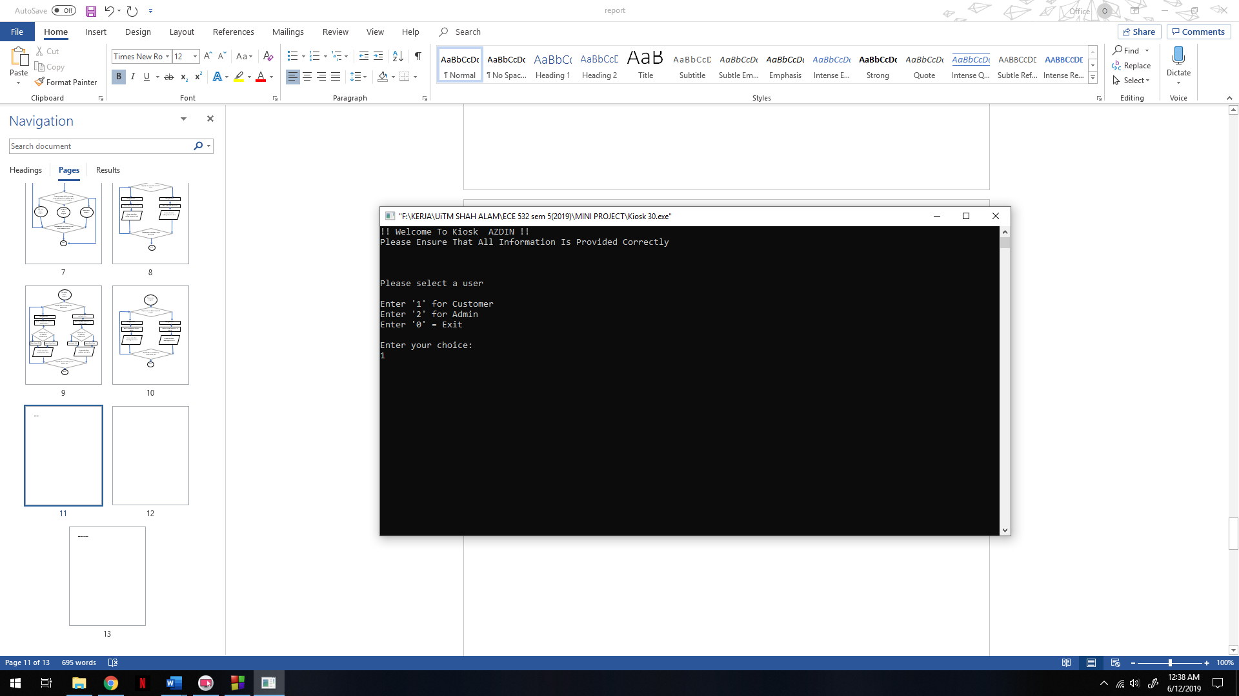

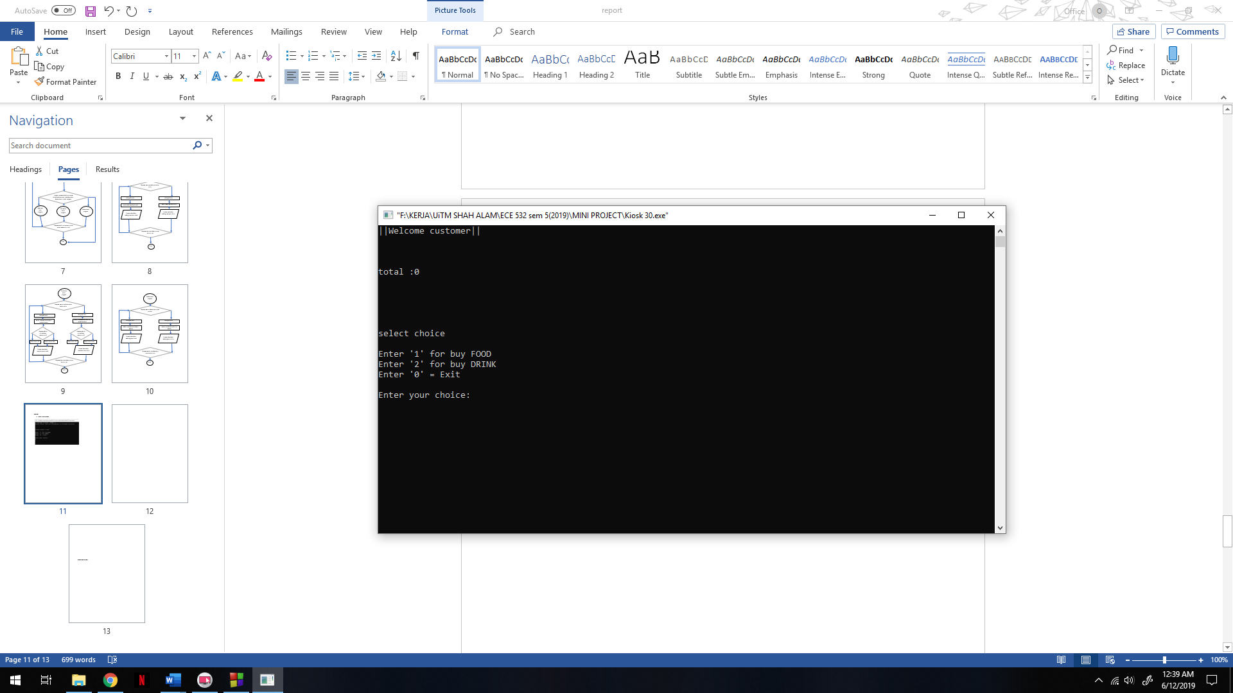

**If customer choose to buy food**

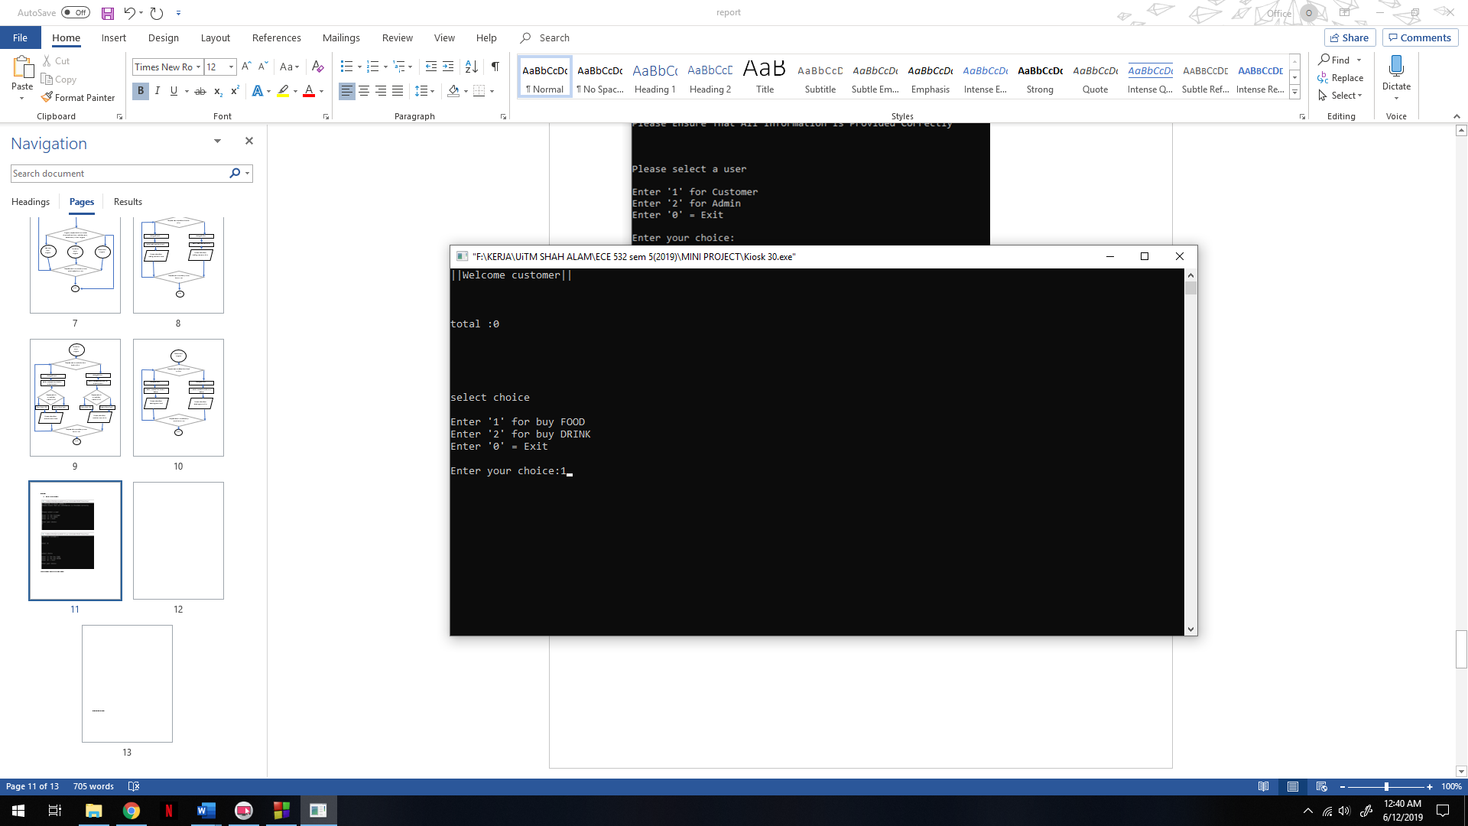

**Customer can choose either want to to buy another food or done**

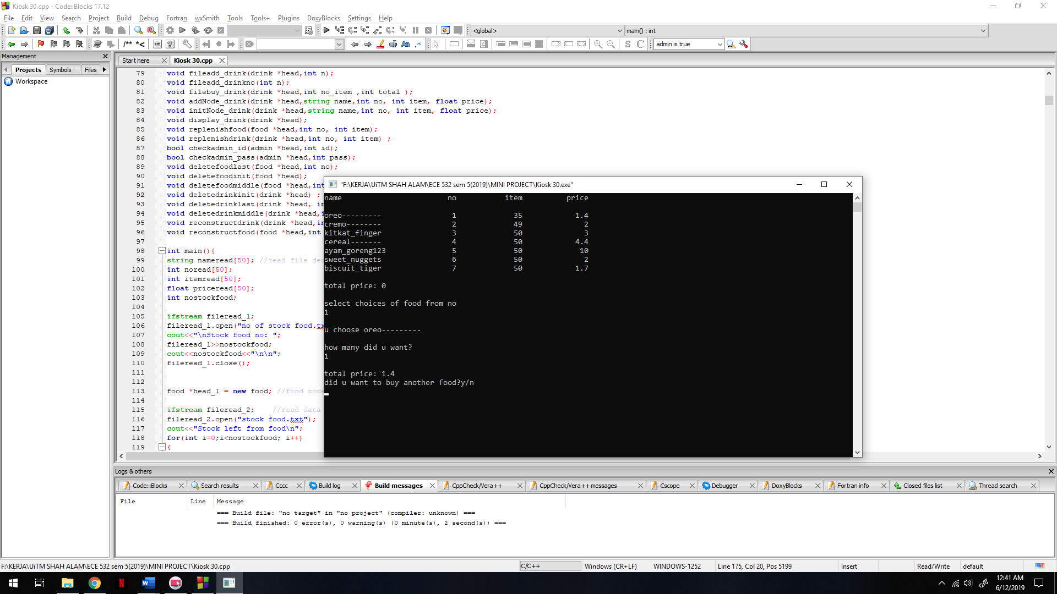

**Customer will go back to make decision either want to buy another or exit**

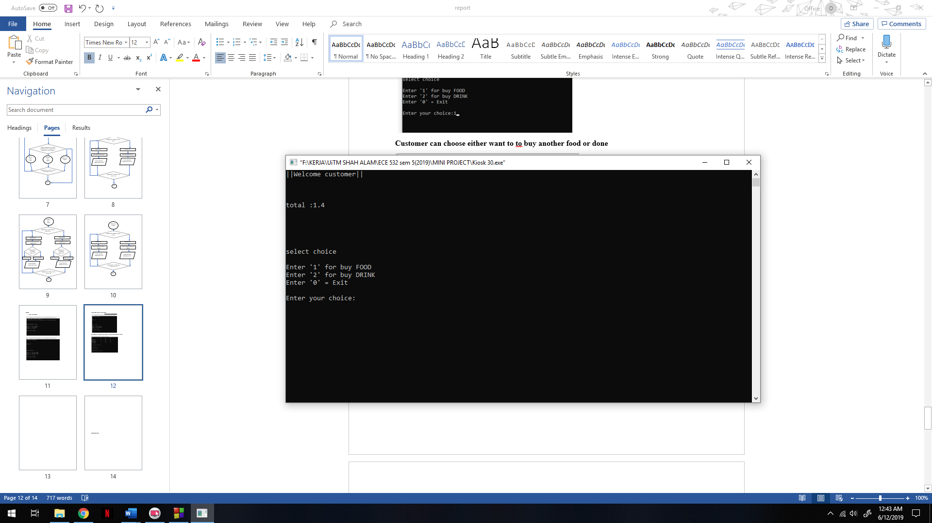

**Customer want to buy another for example drink**

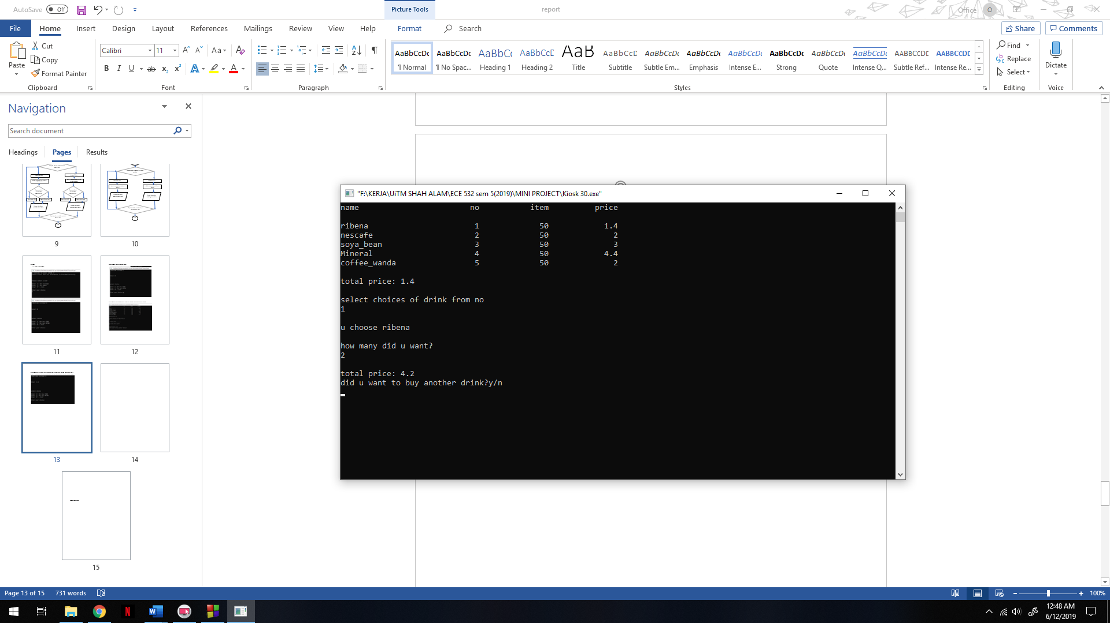

**Customer finish buying desired item and want to checkout**

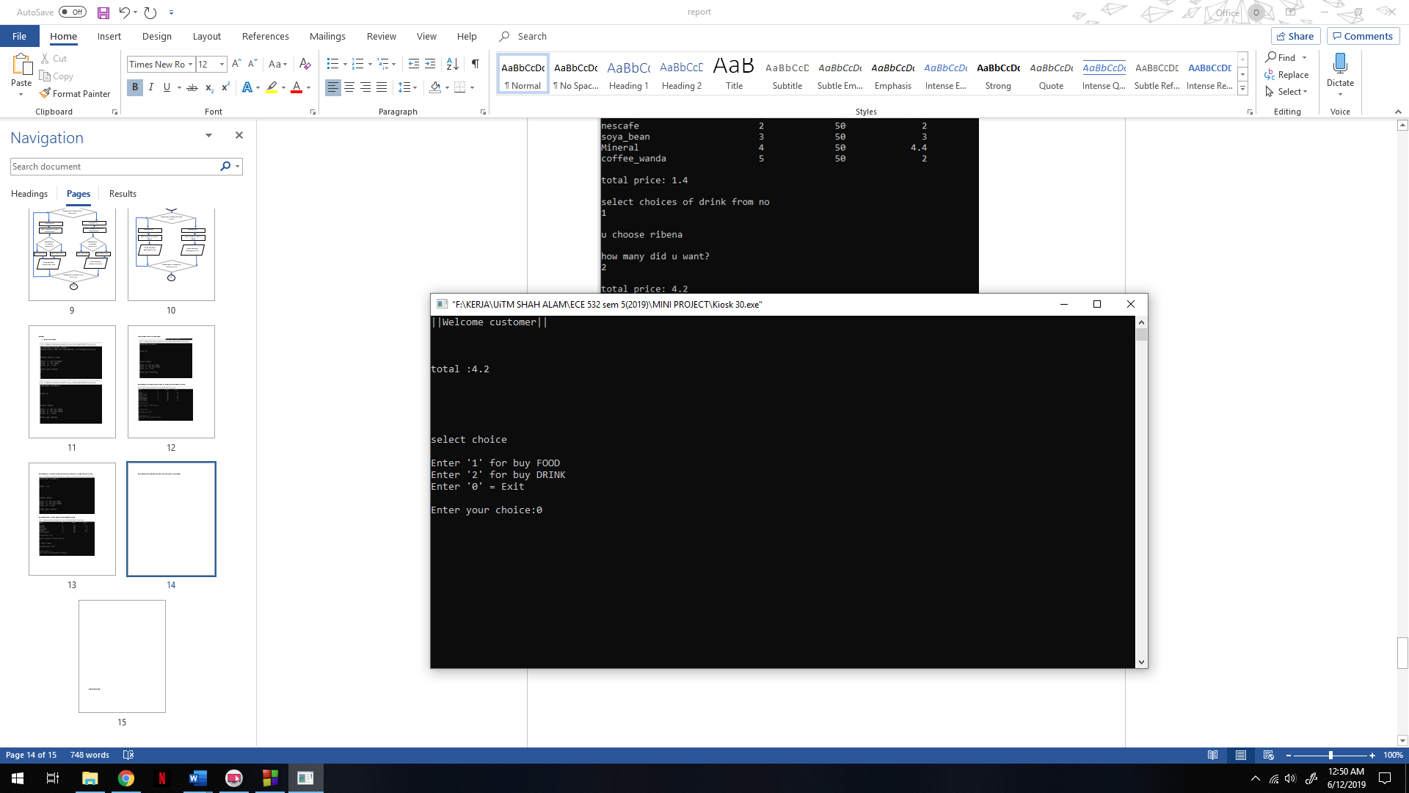

**Customer need to enter name for invoice**

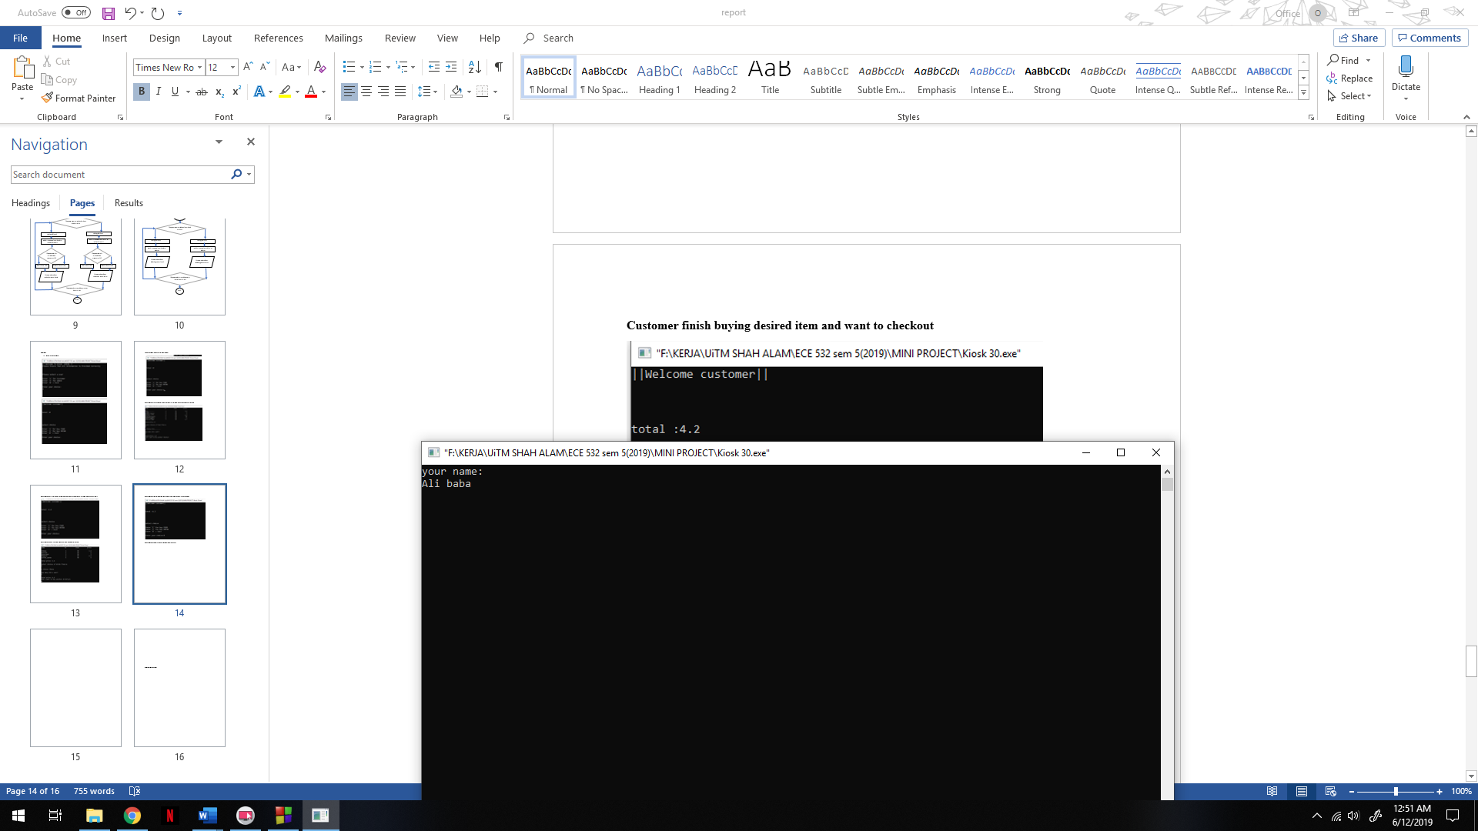

**Customer need to enter address for delivery**

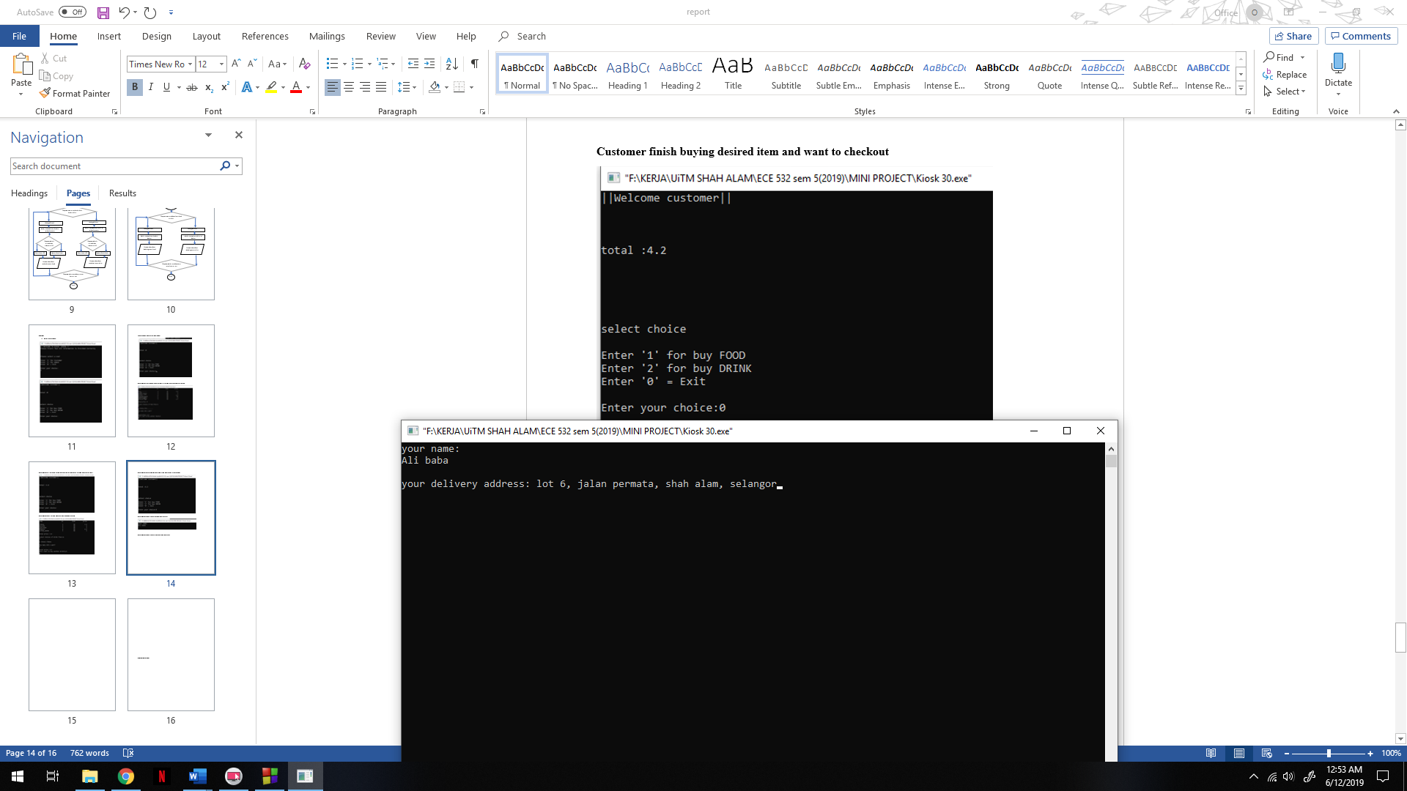

**Customer will be given invoices with name , address to delivery and total price**

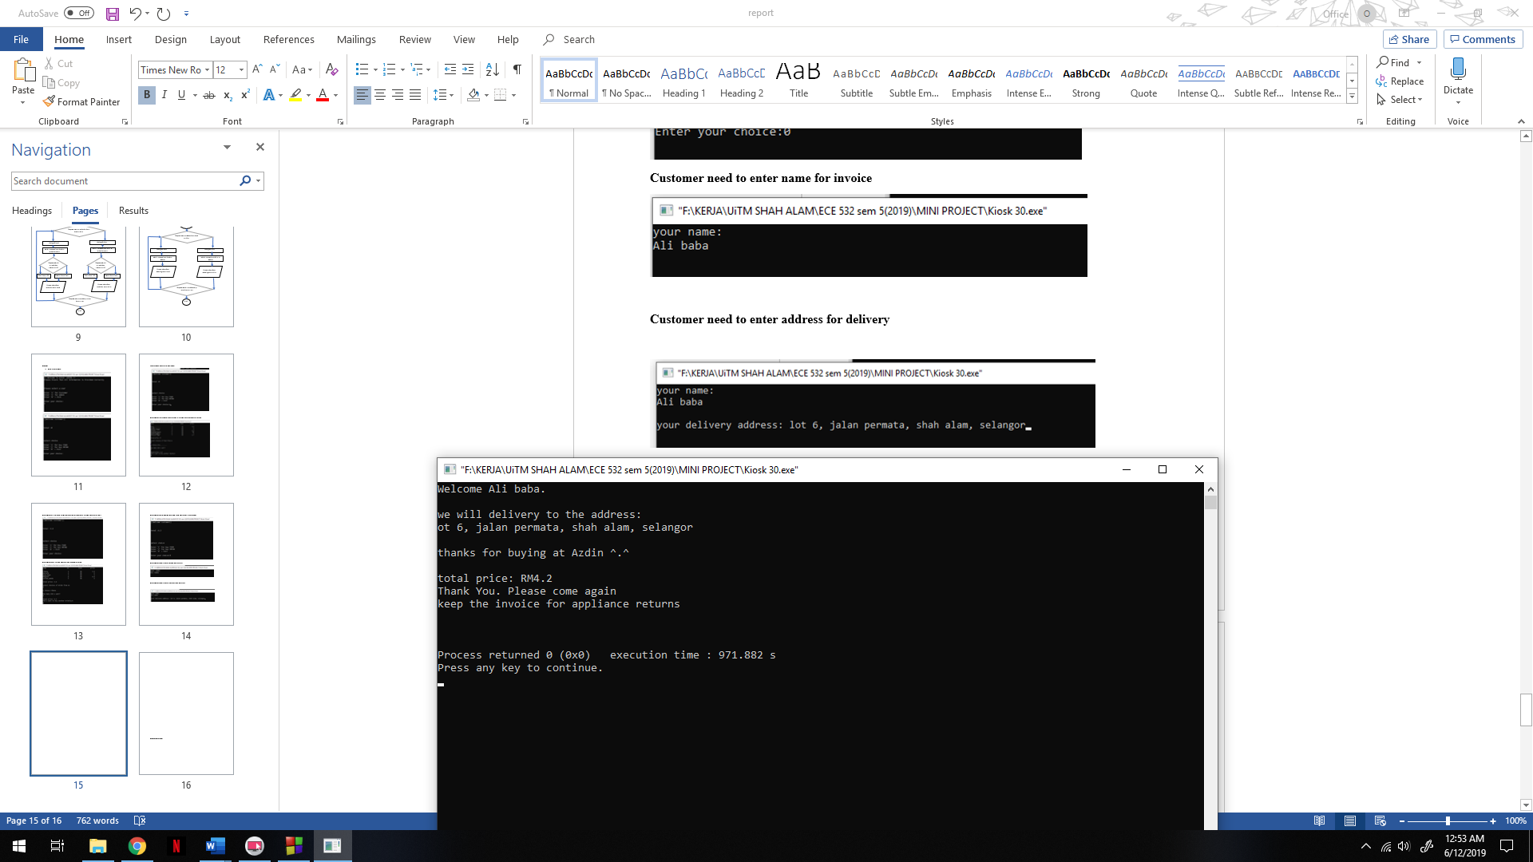

1. **Editing as admin**

**Admin will choose no 2.**

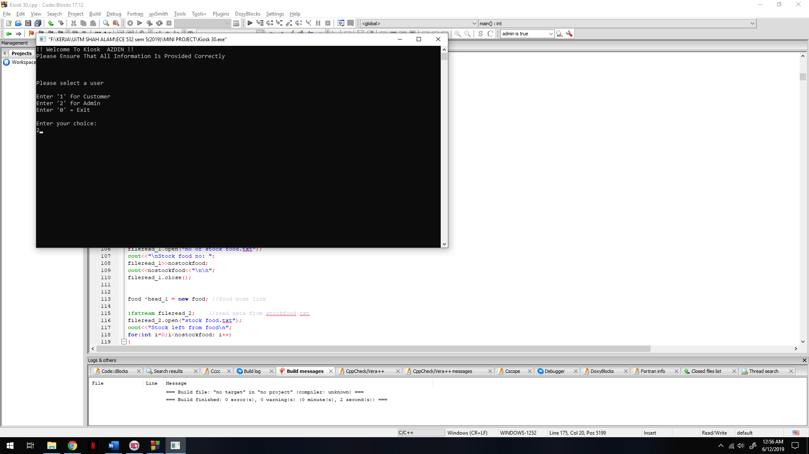

**Admin need to put id and password to verify and if false try again**

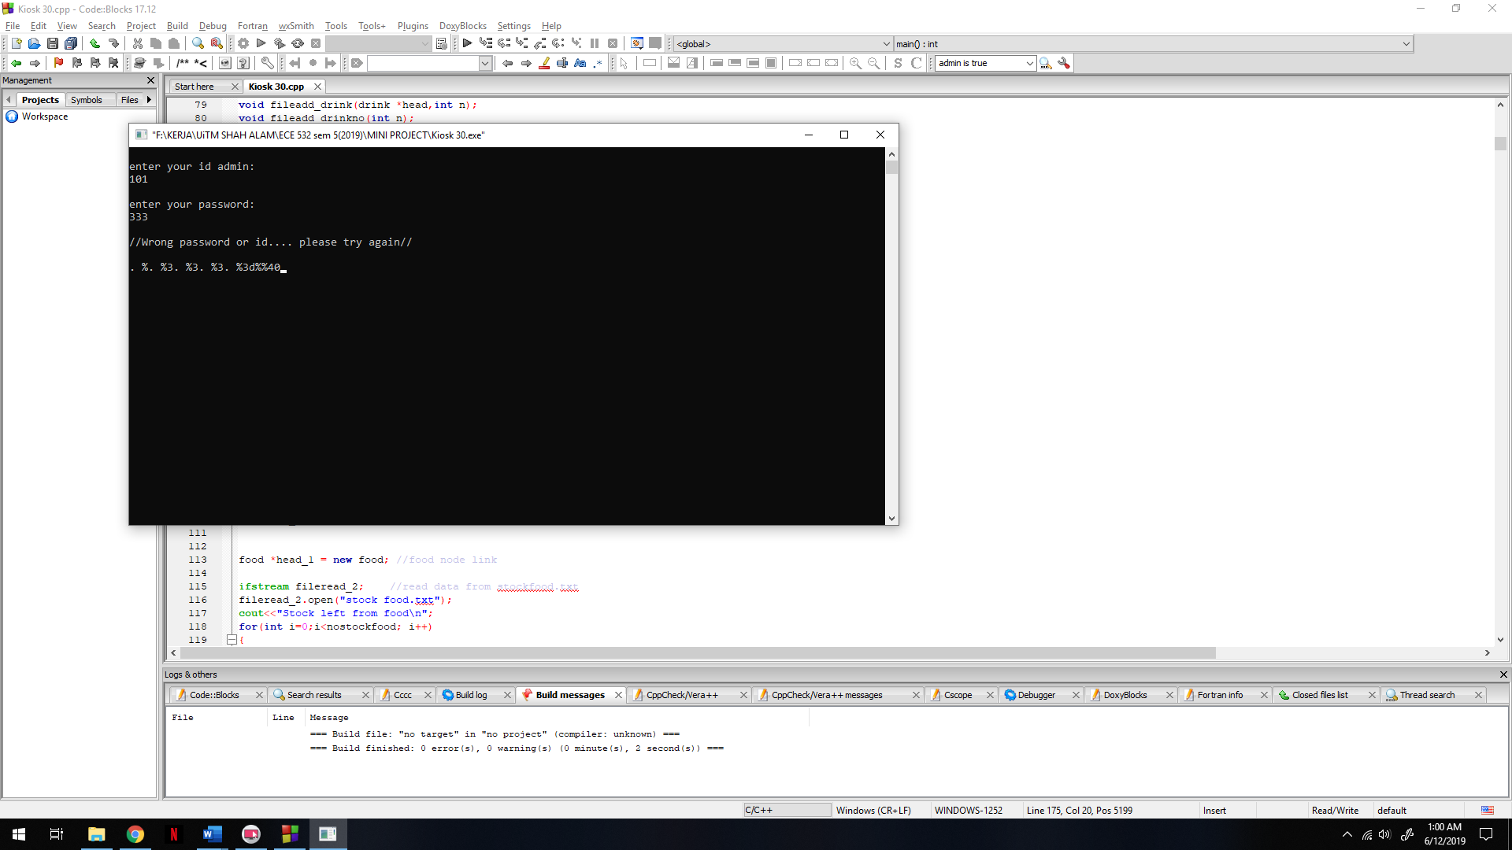

**If verified is true**

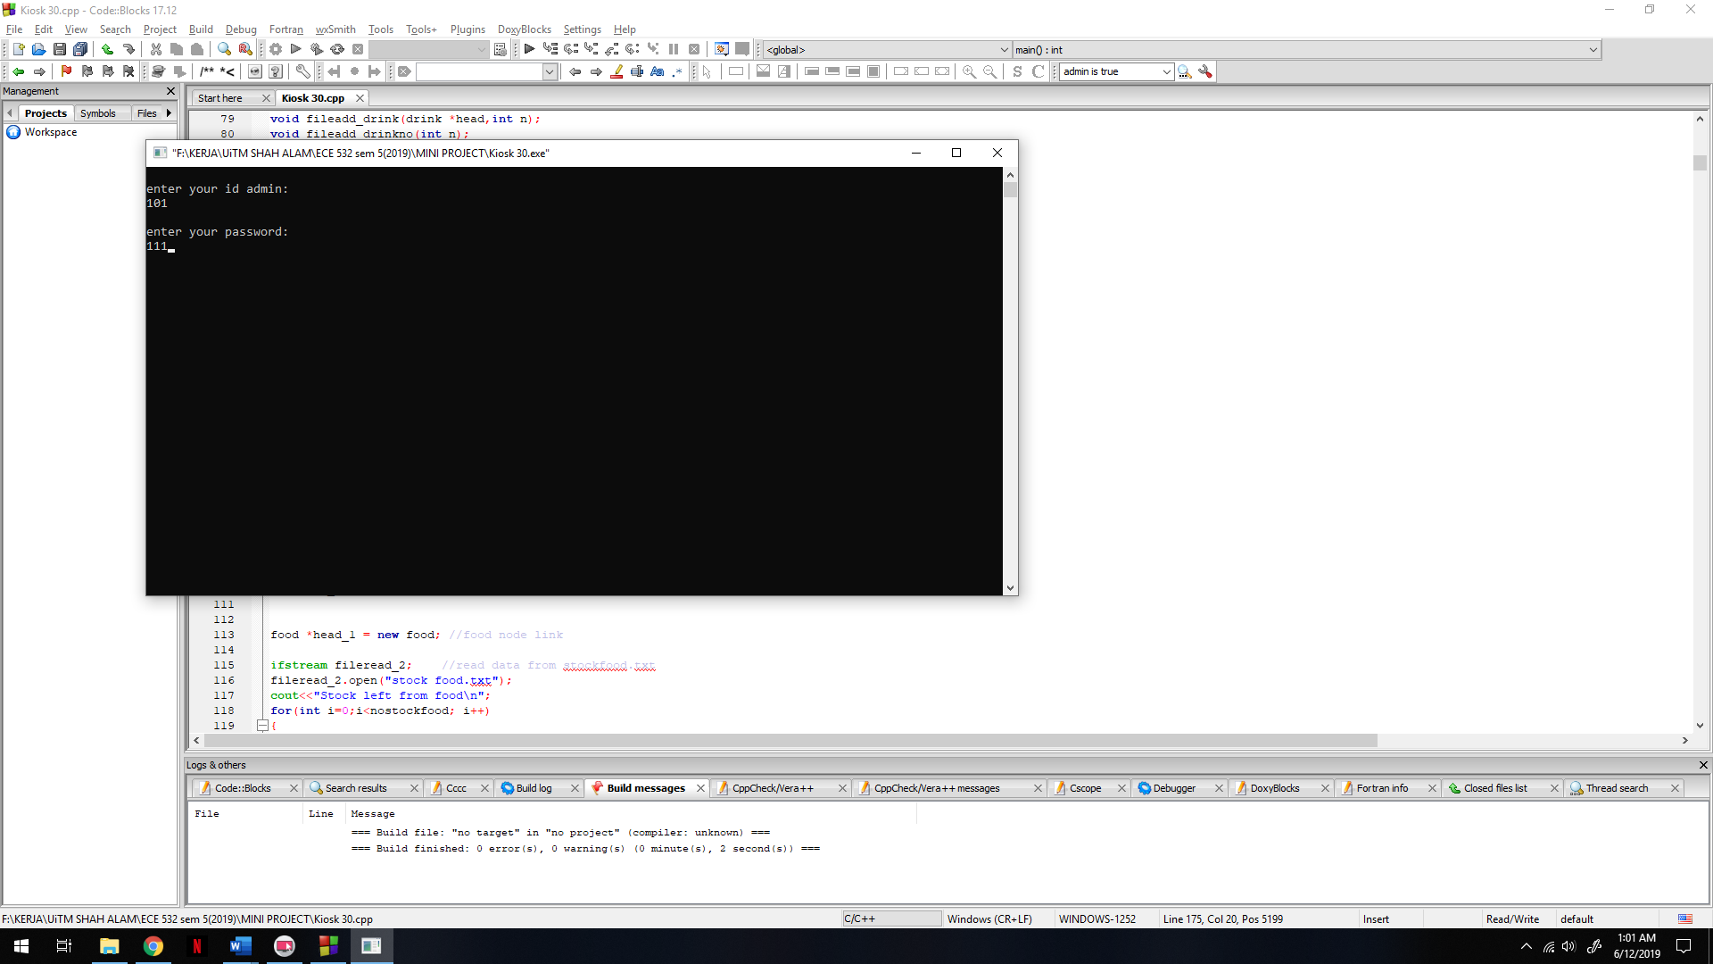

**Admin will be give option to edit data**

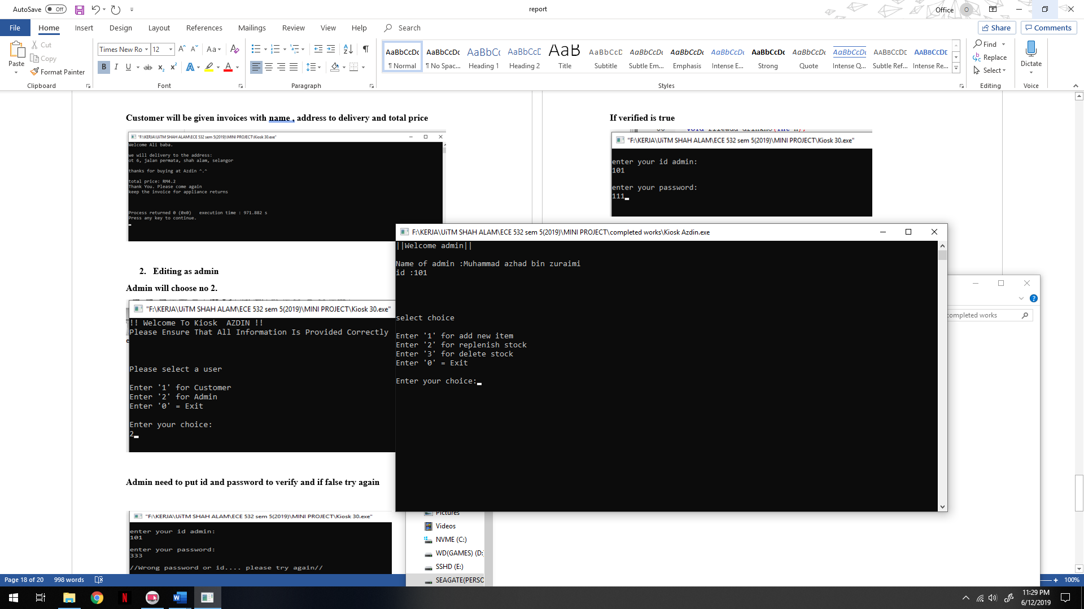

**If choose ‘1’ which is add new item**

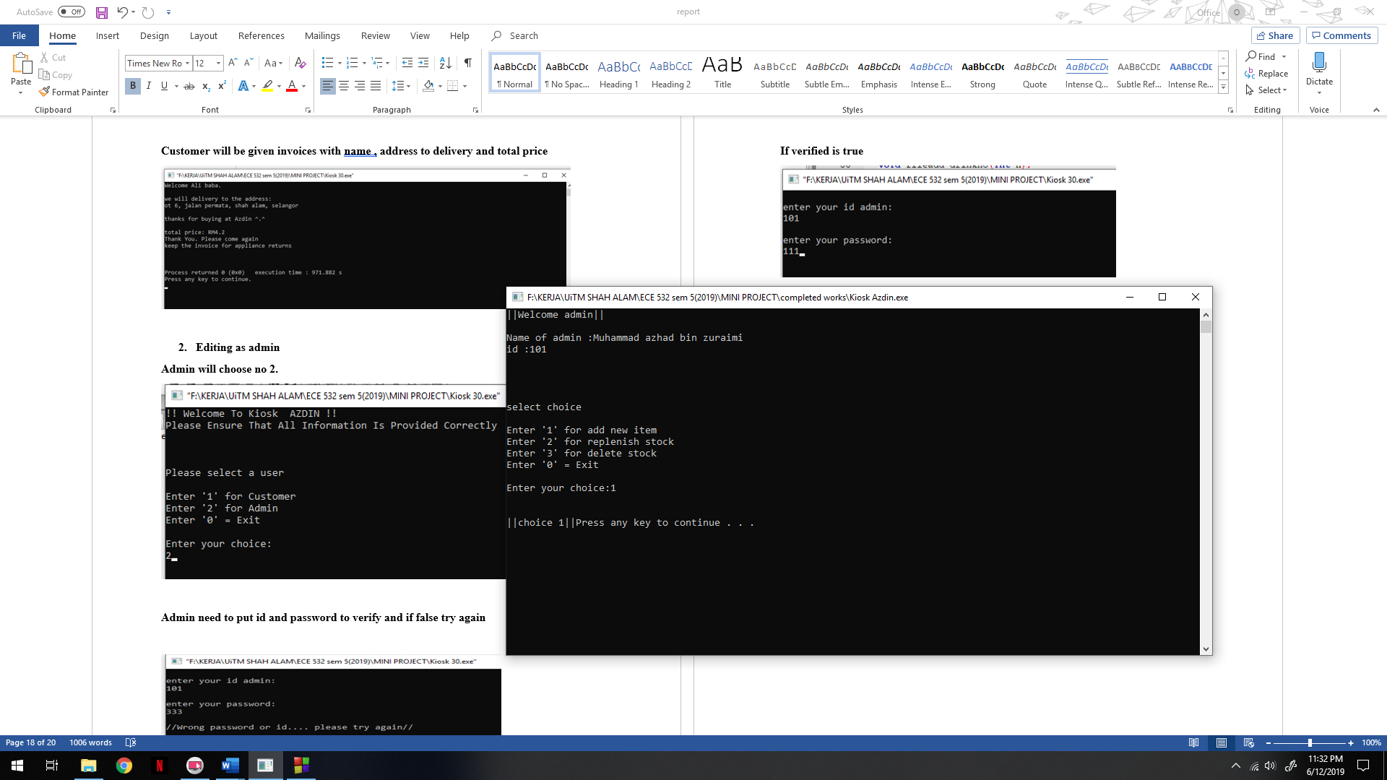

**Admin will be given choices to add new item either food or drink**

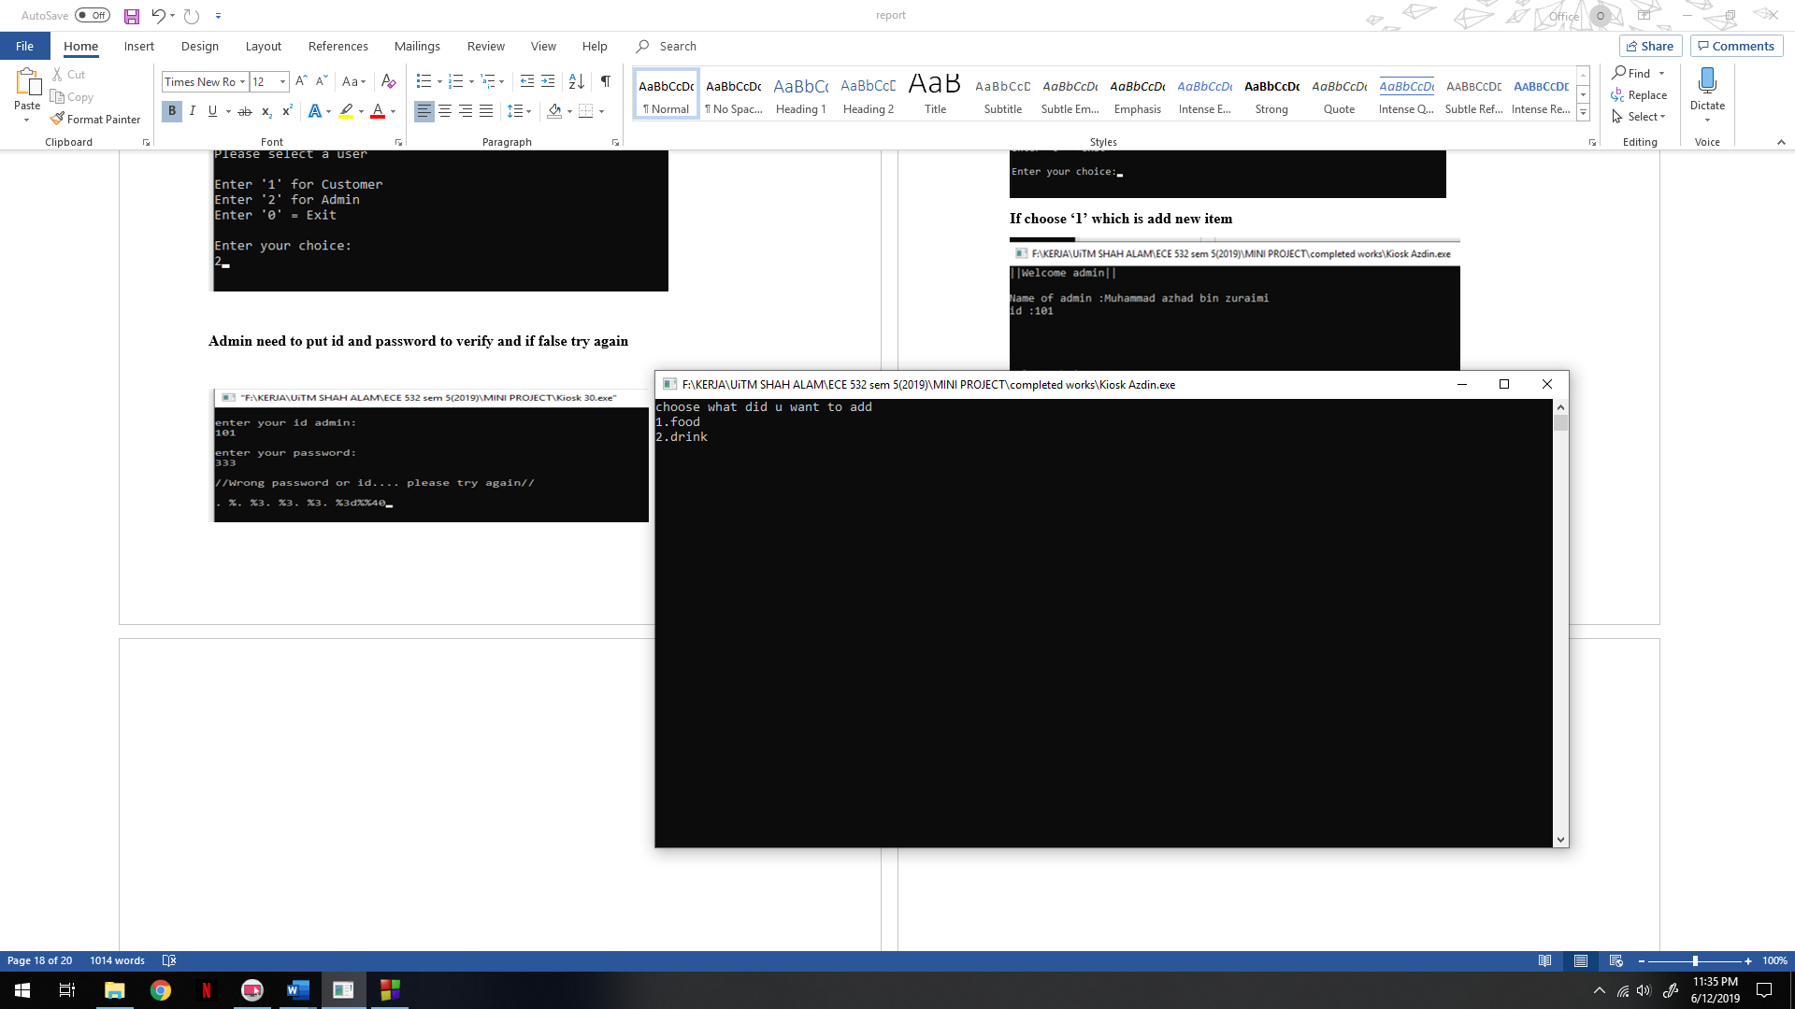

**Example add new food**

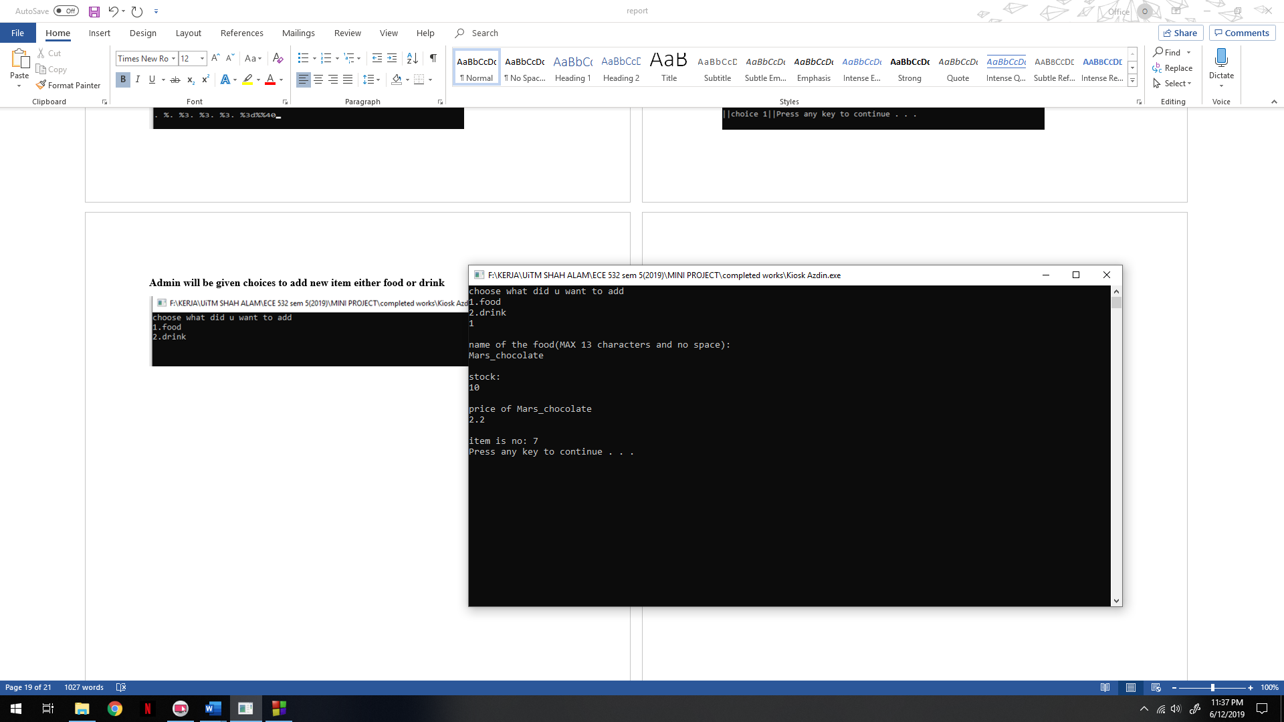

**Then will show the added node and question admin to add other or not**

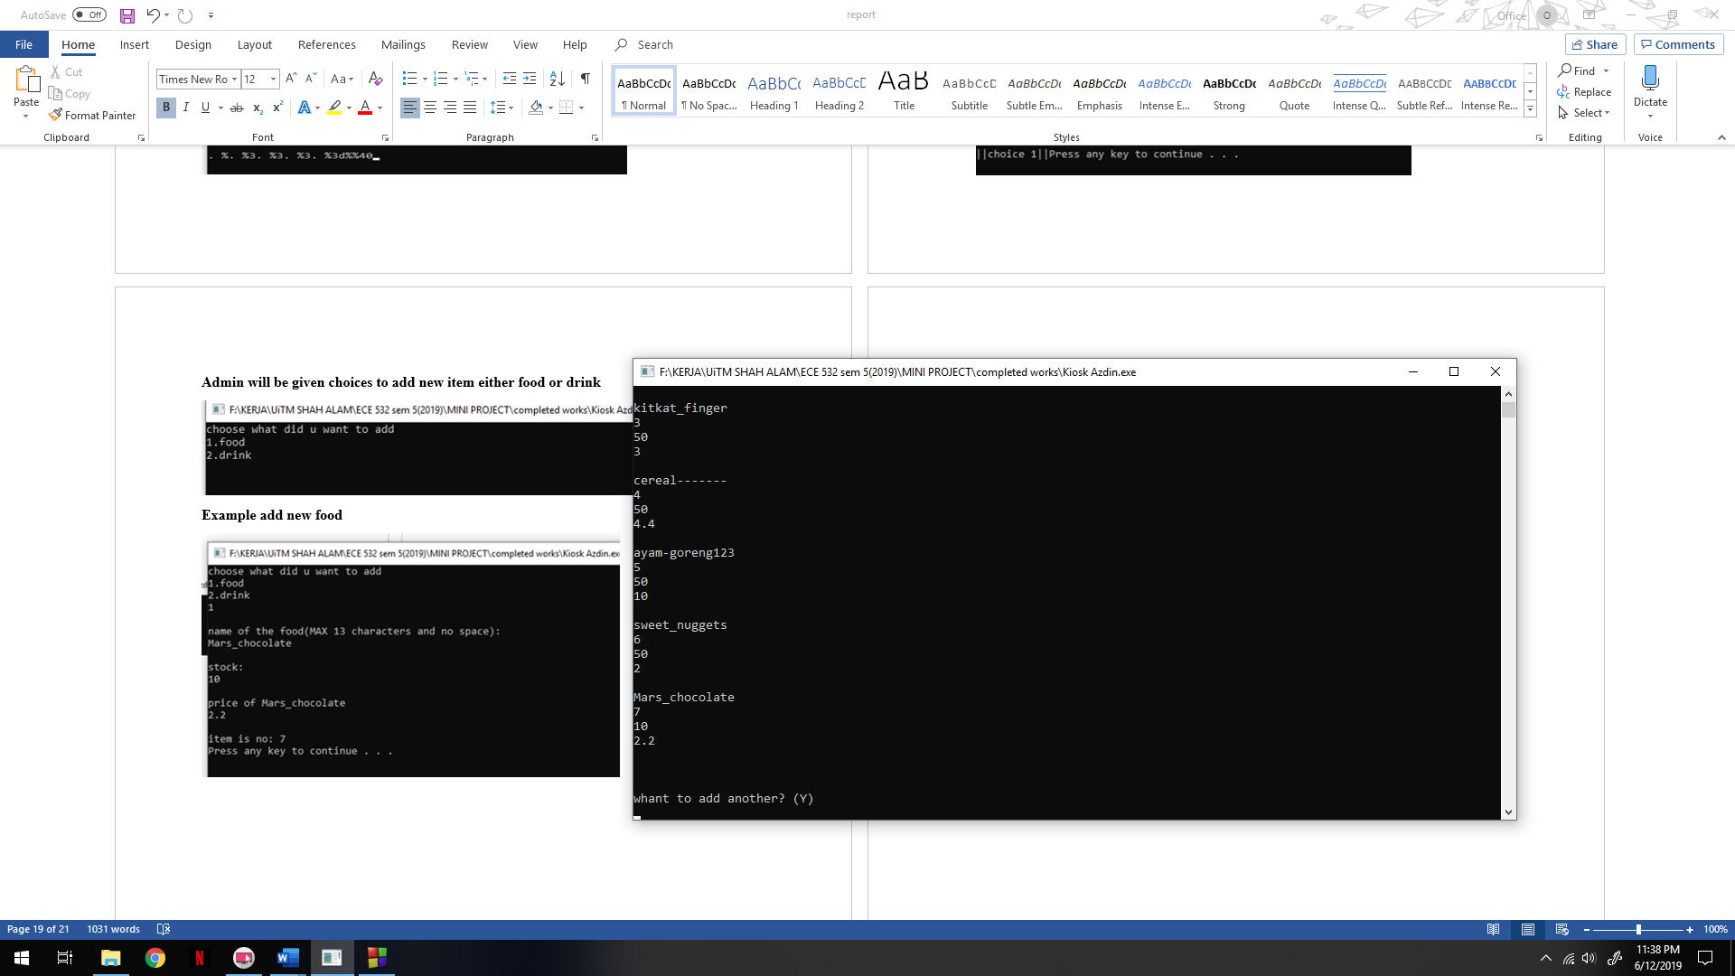

**Admin will go back to given choices to add new item either food or drink**



**Example add new drink**

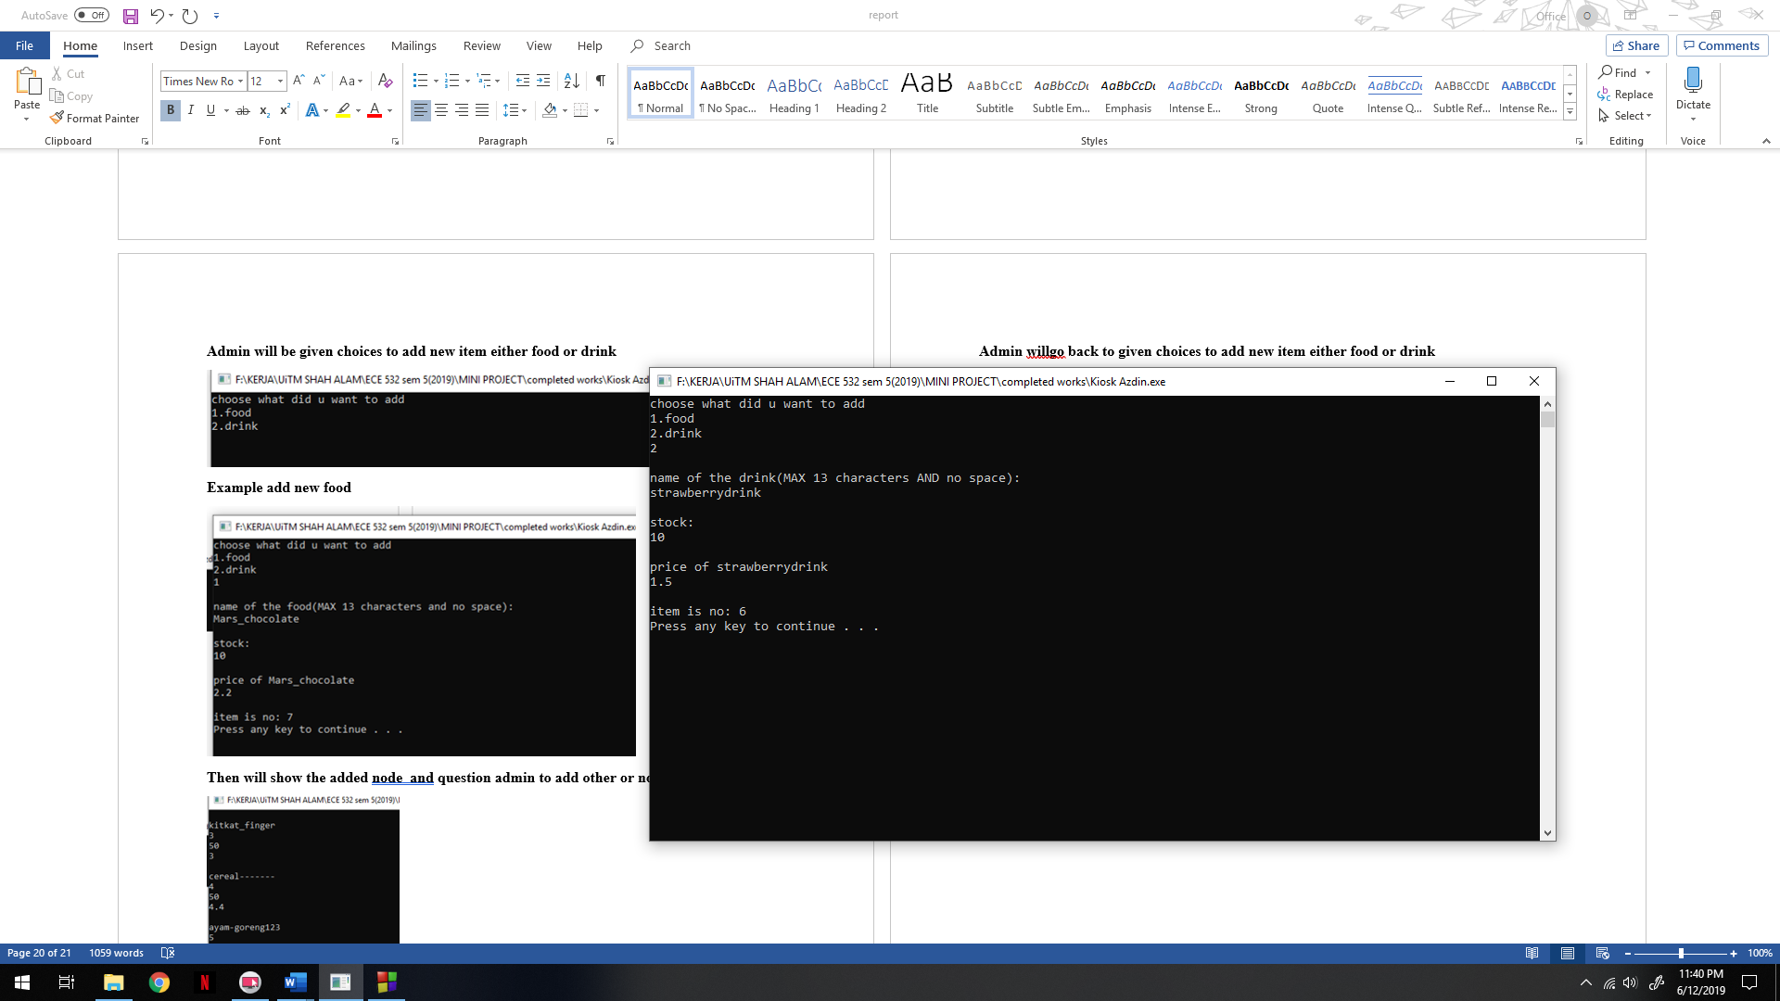

**Then will show the added node and question admin to add other or not**

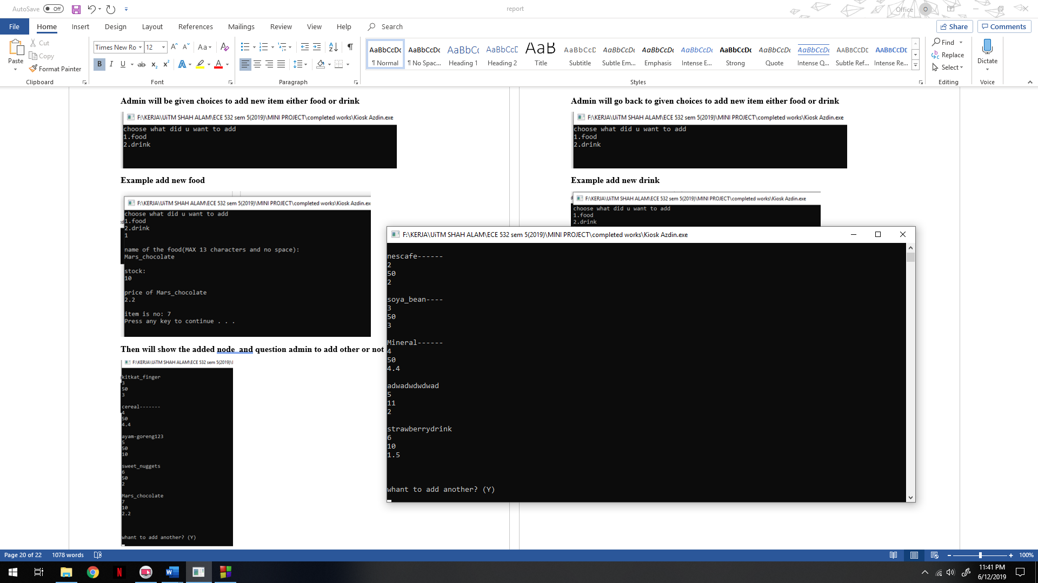

**Example updated file food after the update info**

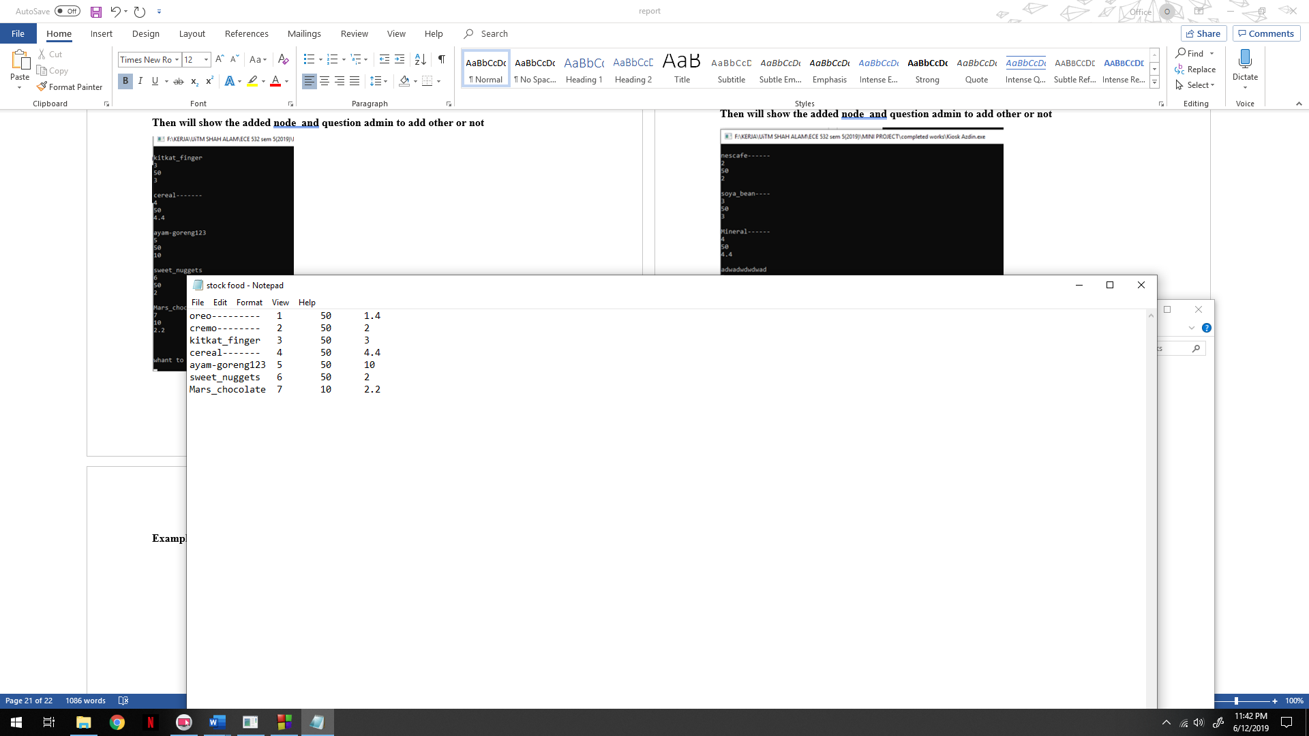 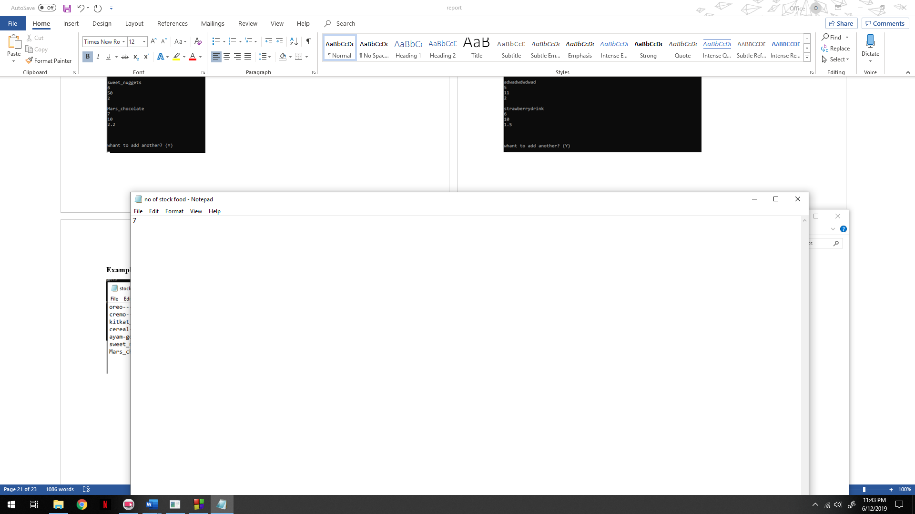

**Example updated file drink after update info**

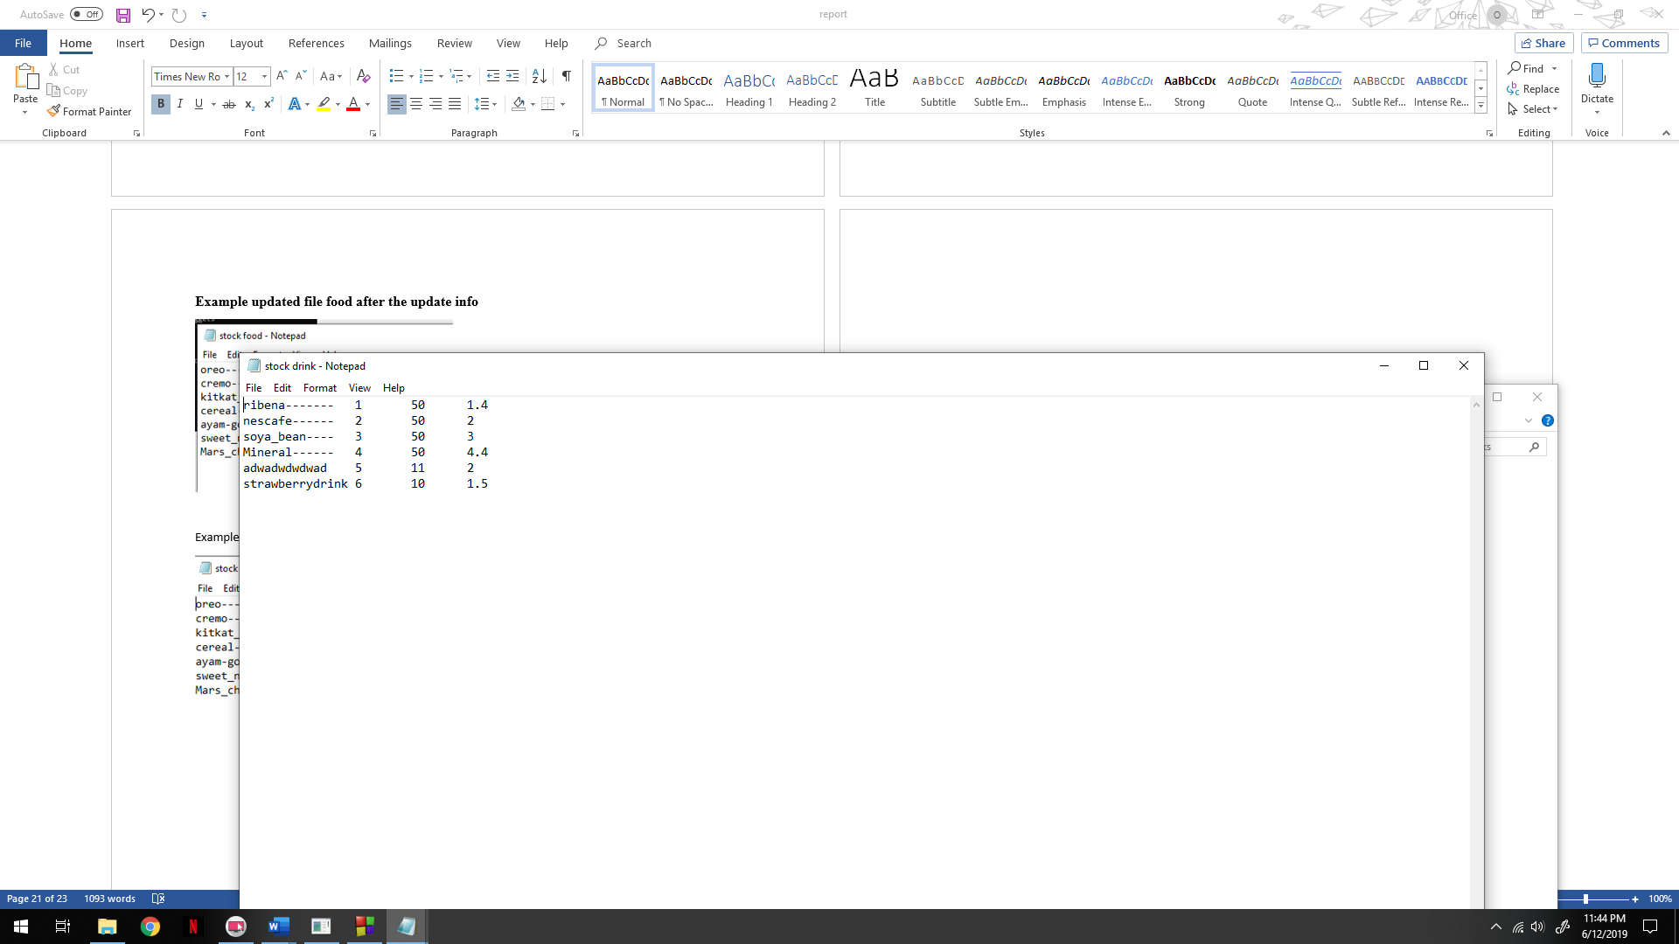 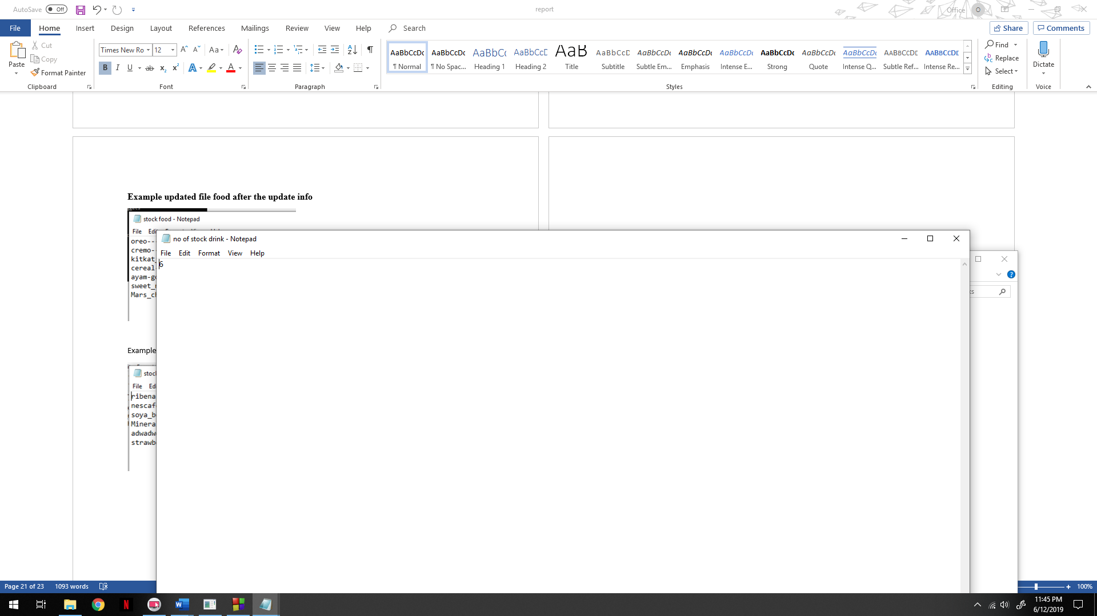

**If make to choose to make other decision will go back to editing admin menu.**

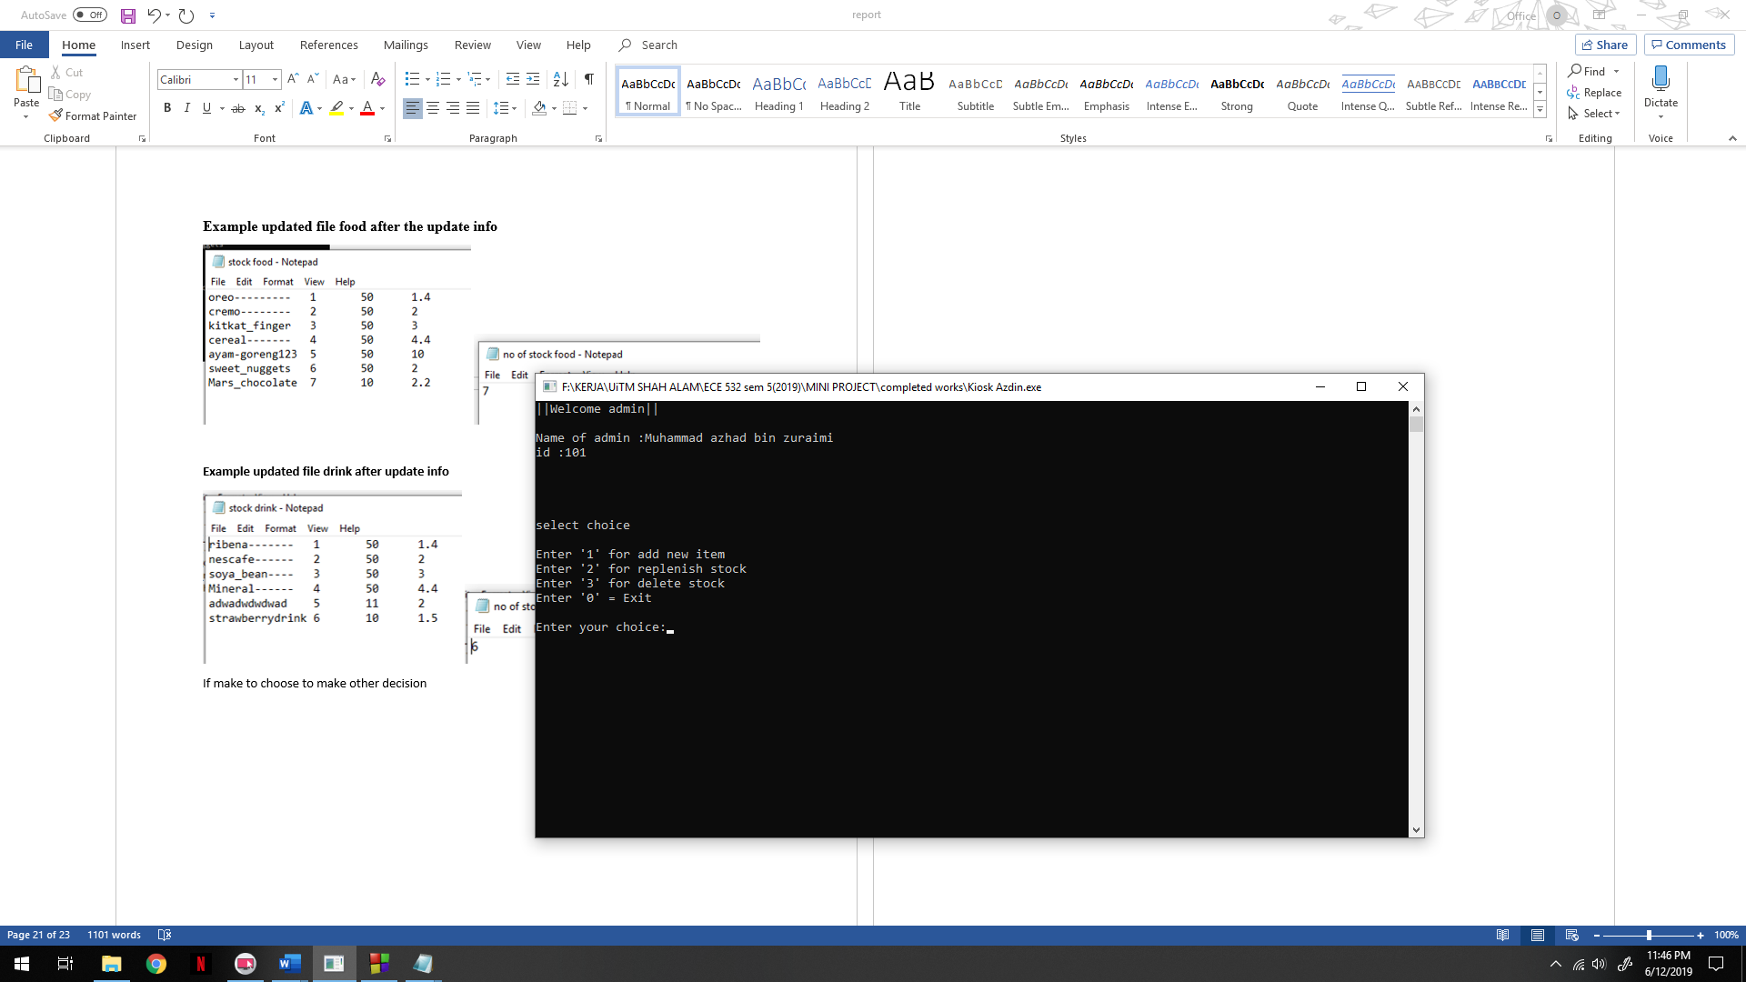

**If choose to replenish stock admin press 2**

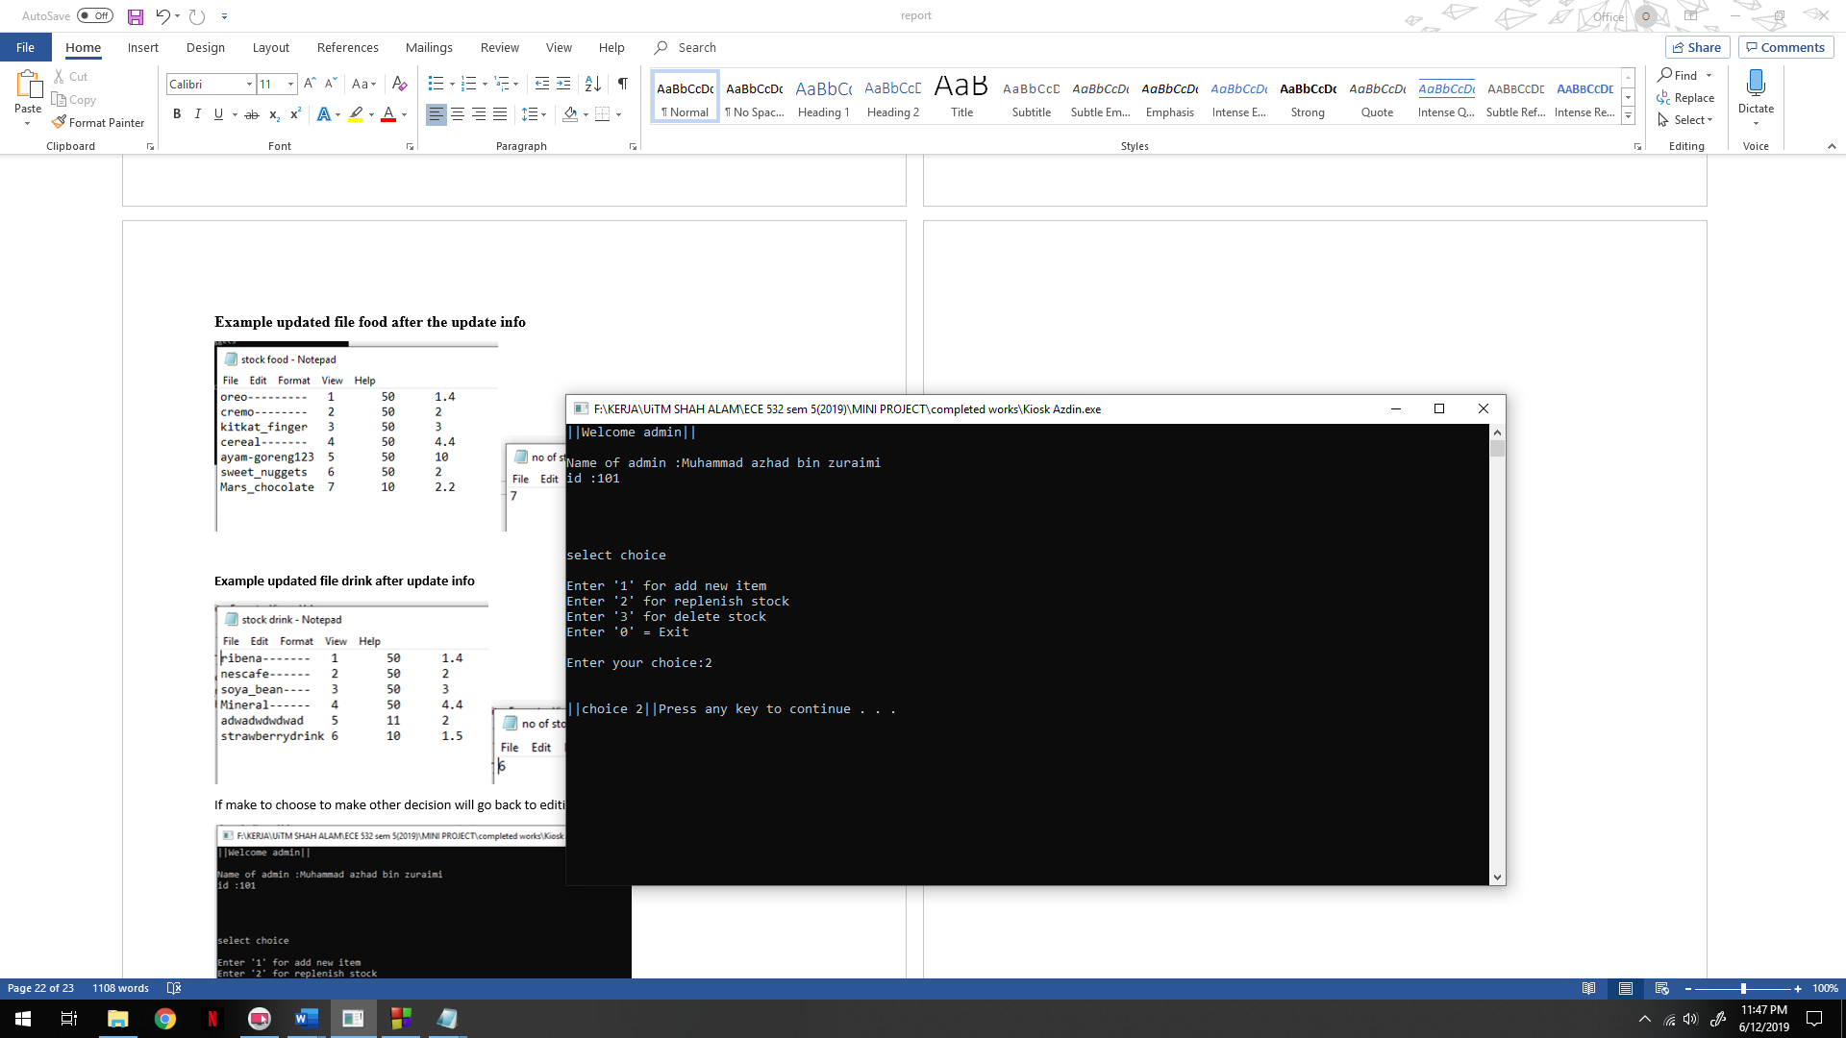

**Admin will be question to replenish food or drink.**

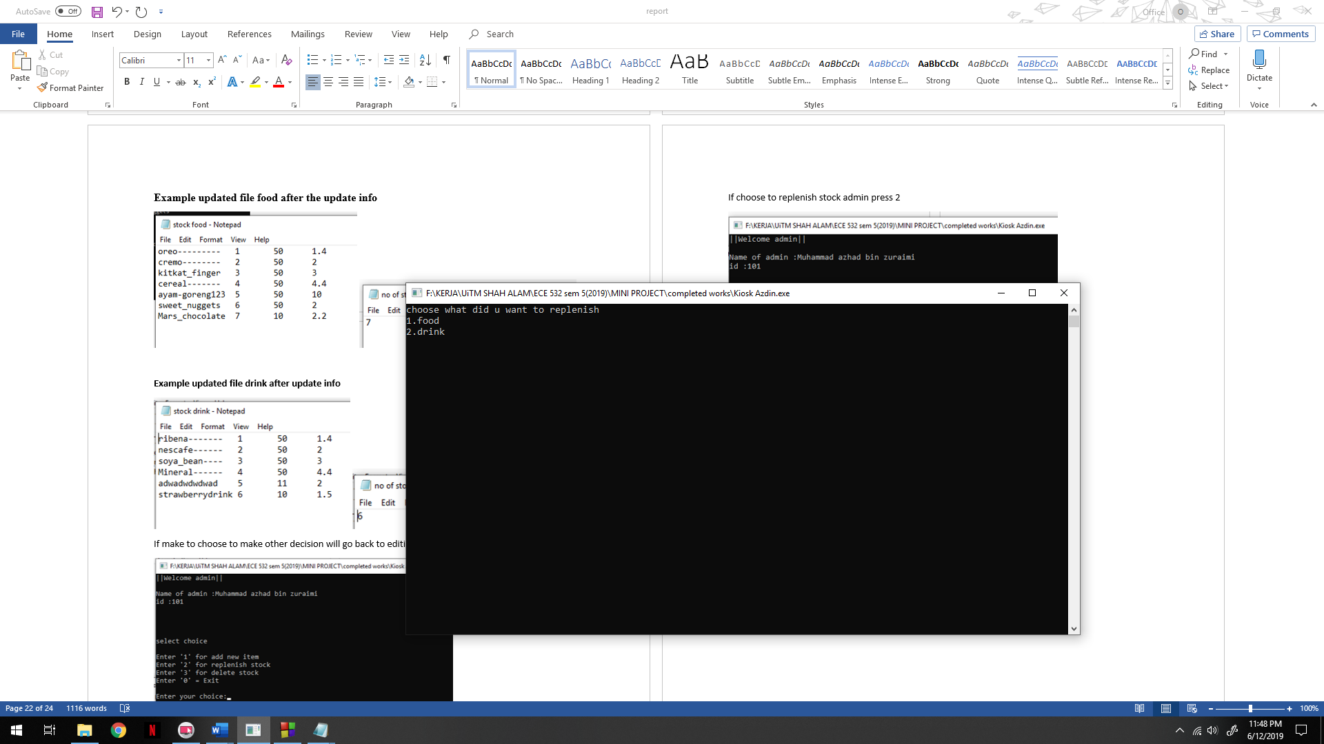

**Example admin want to replenish cremo with 70 stock**

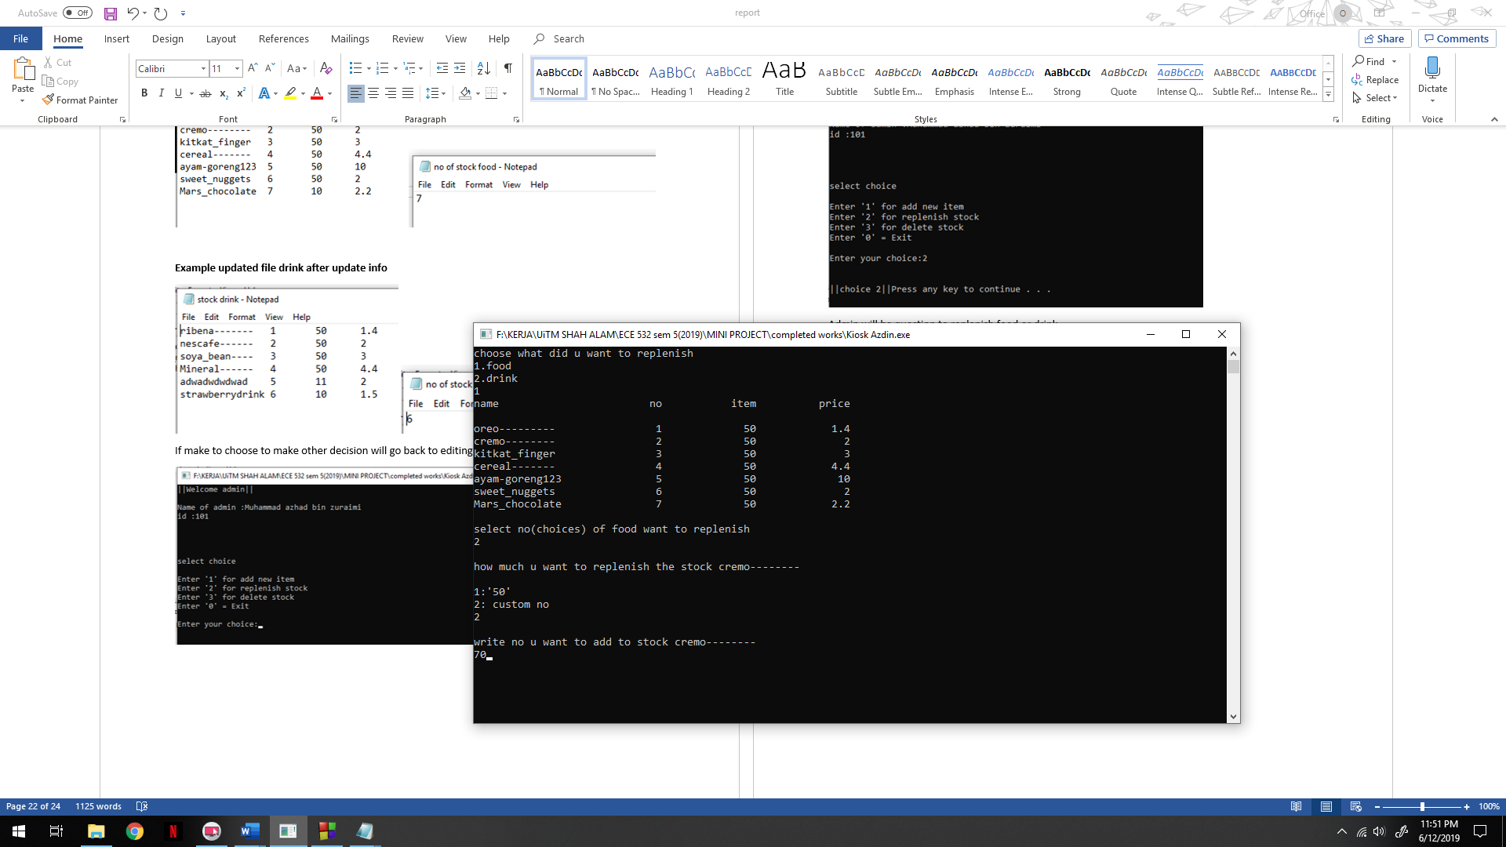

**The after effect cremo is add by 70 stock given 120 item**

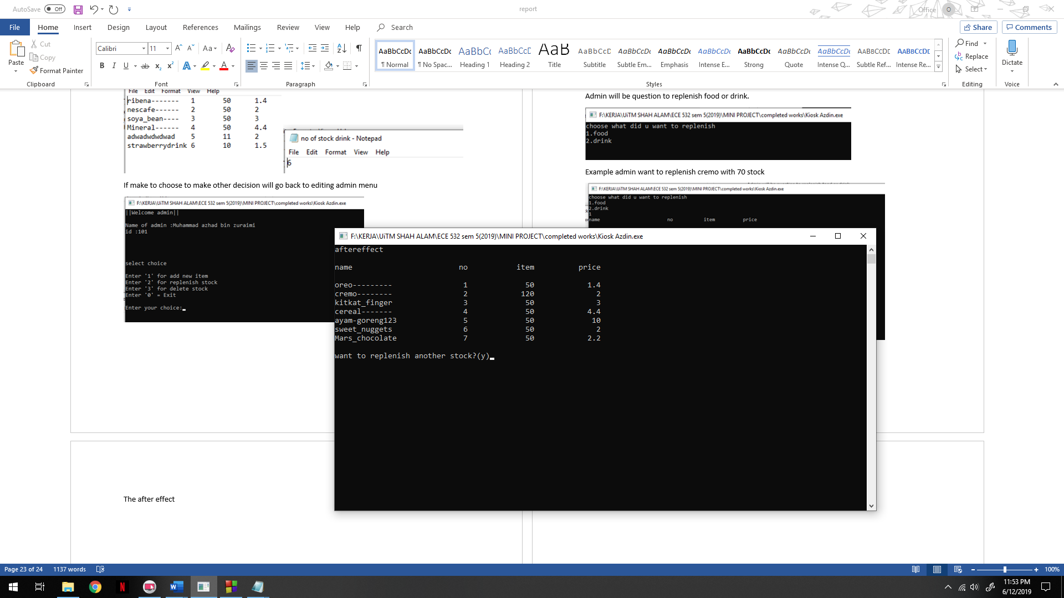

**File stock food updated**

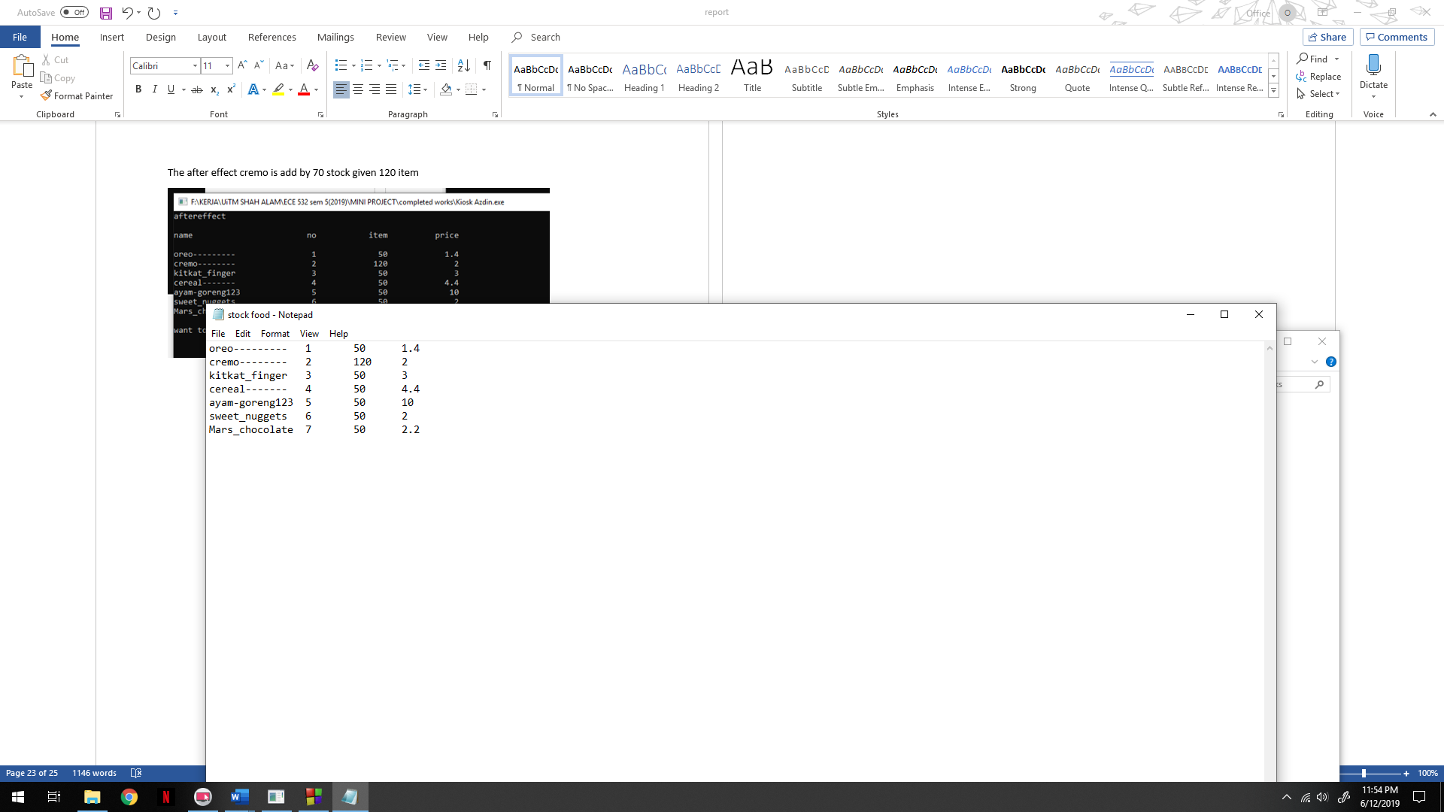

**If choose to replenish another stock**

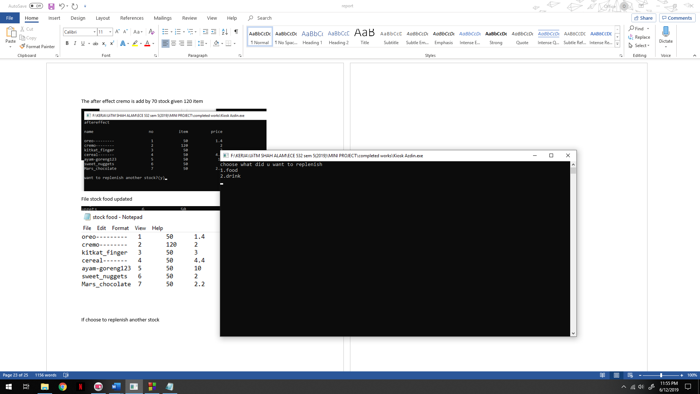

**Example want to replenish drink strawberry to 50**

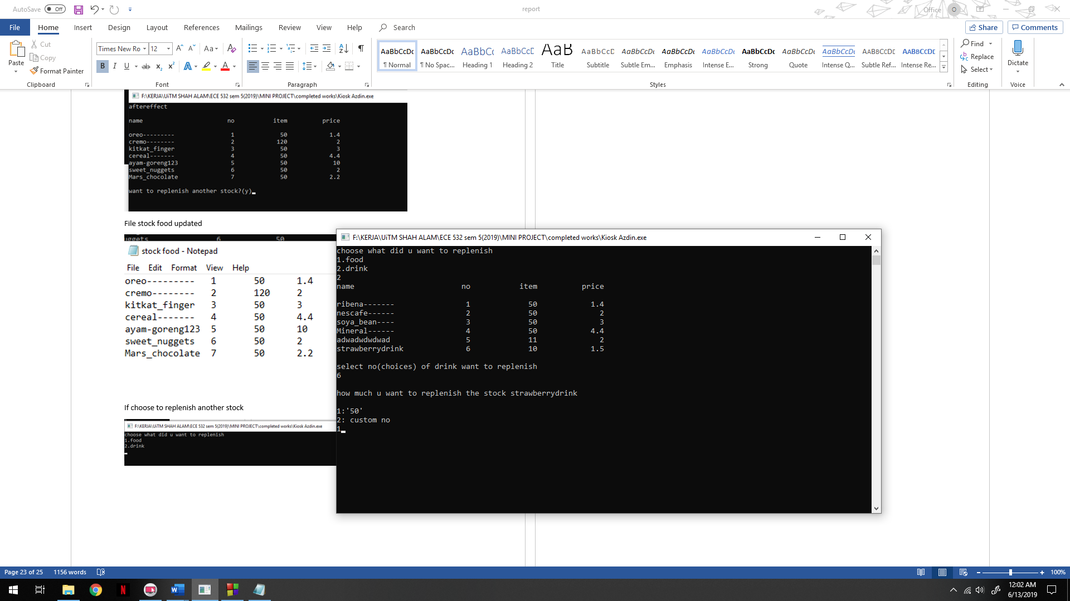

**The after effect replenish drink stock strawberry**

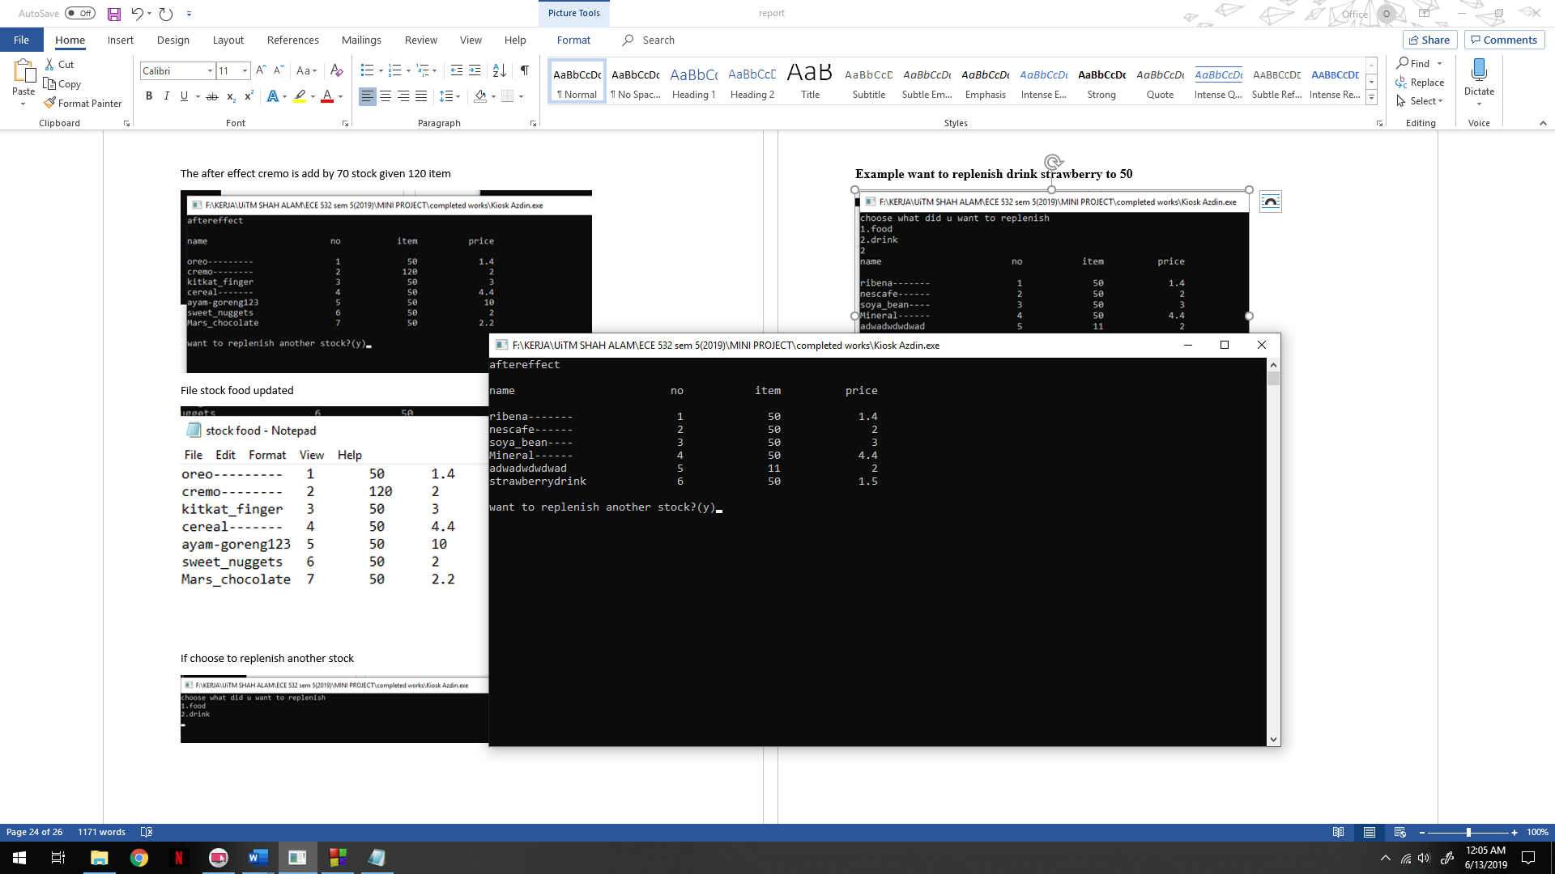

**File drink updated**

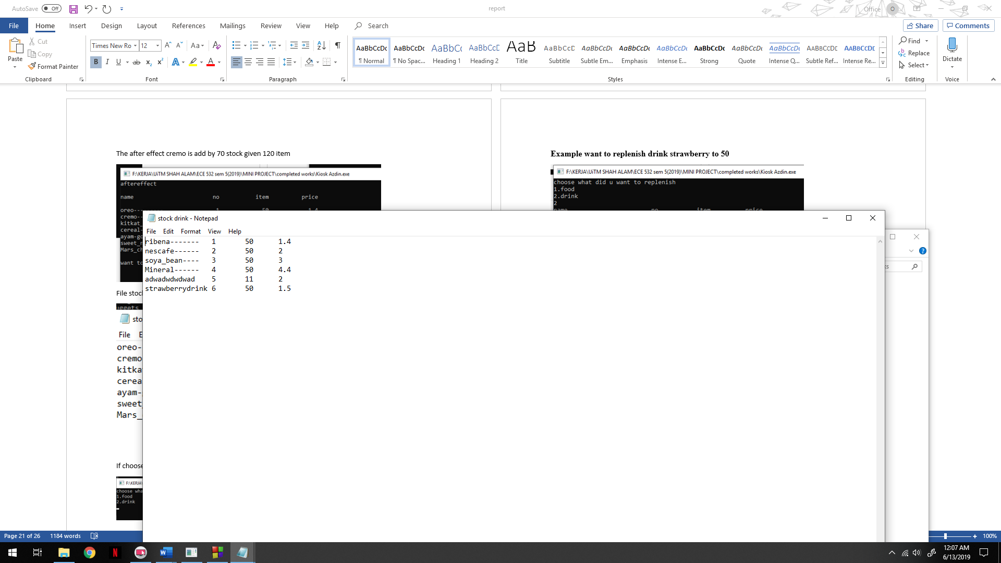

**If choose to make other decision admin will go back to editing menu**

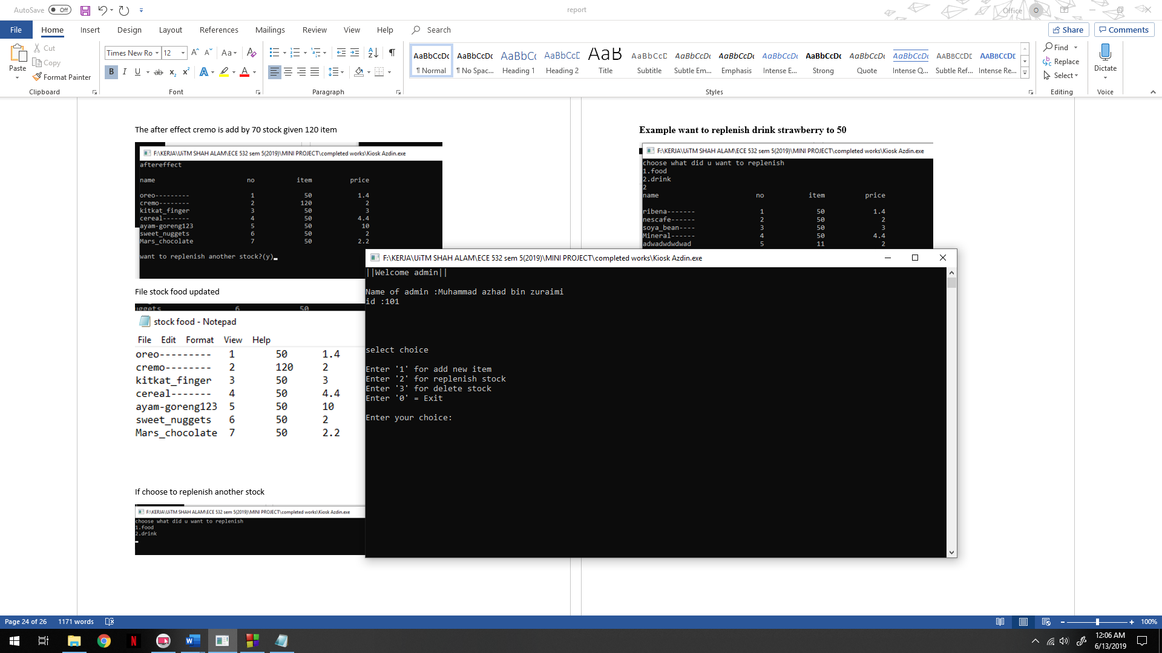

**Admin will choose 3 to delete stock and given option to delete which one**

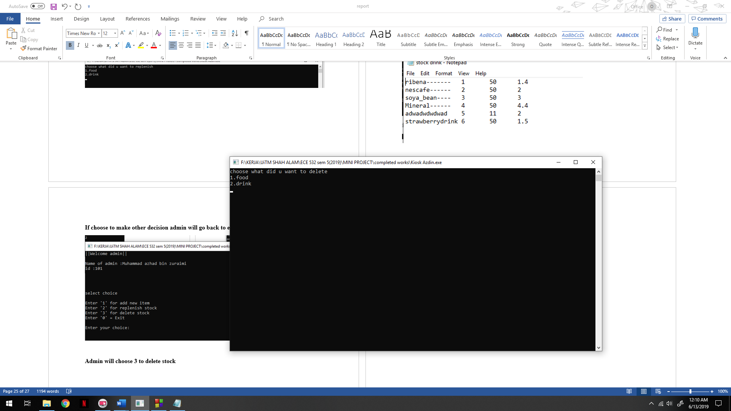

**Example delete first stock (initial node) food.**

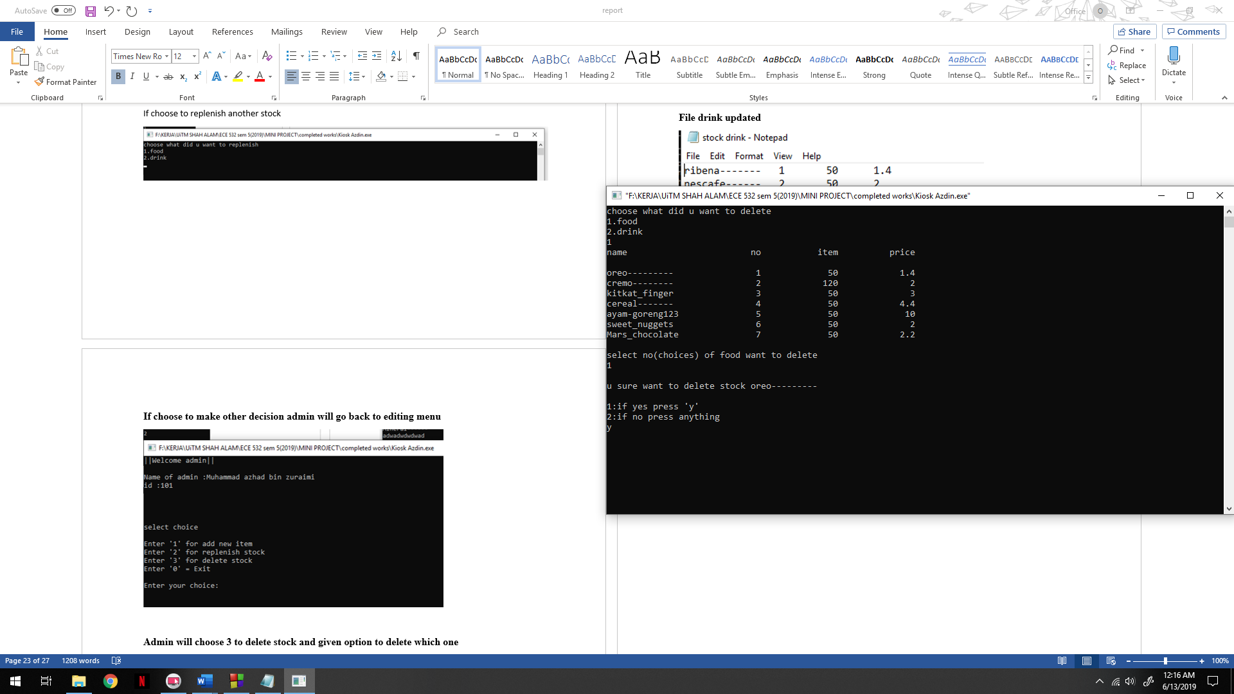

**Aftereffect delete oreo**

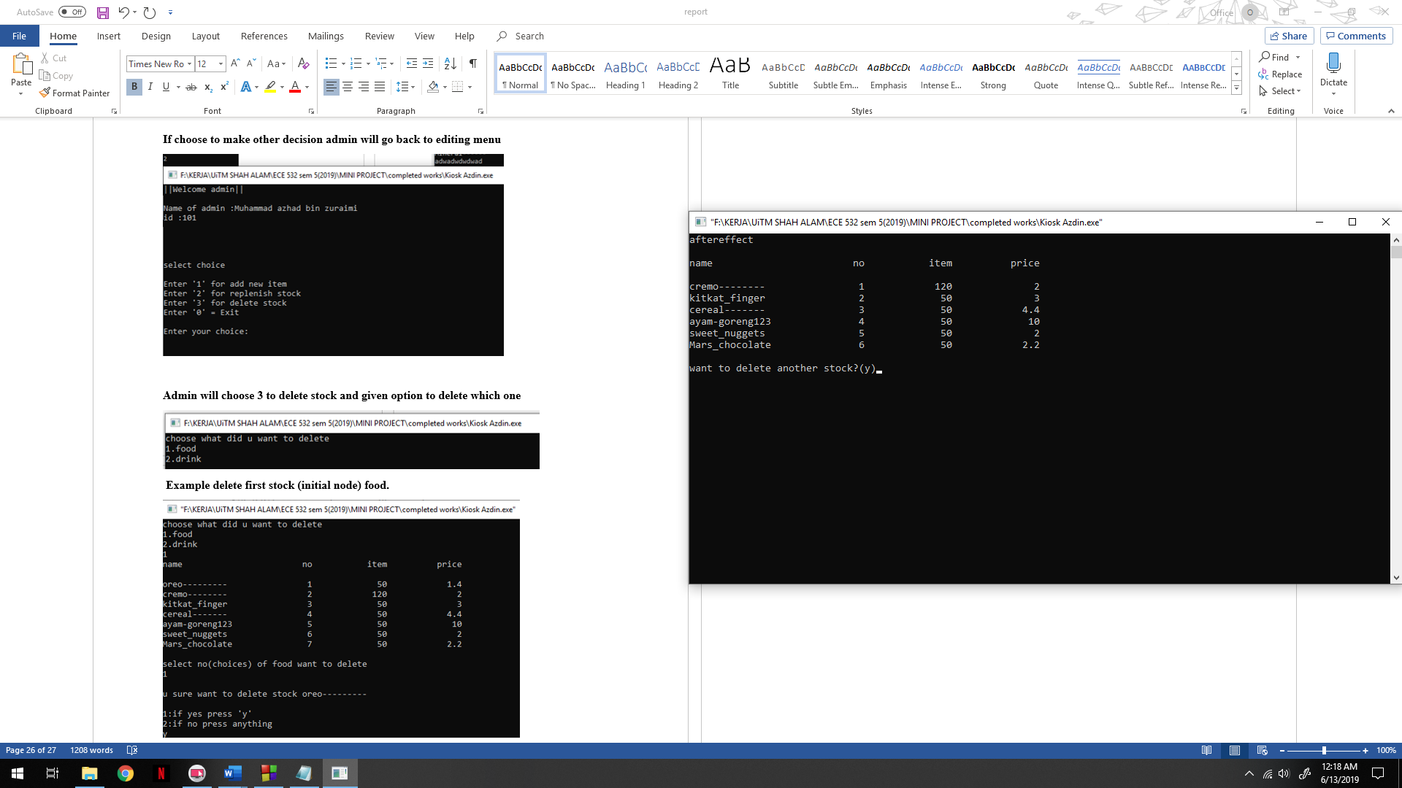

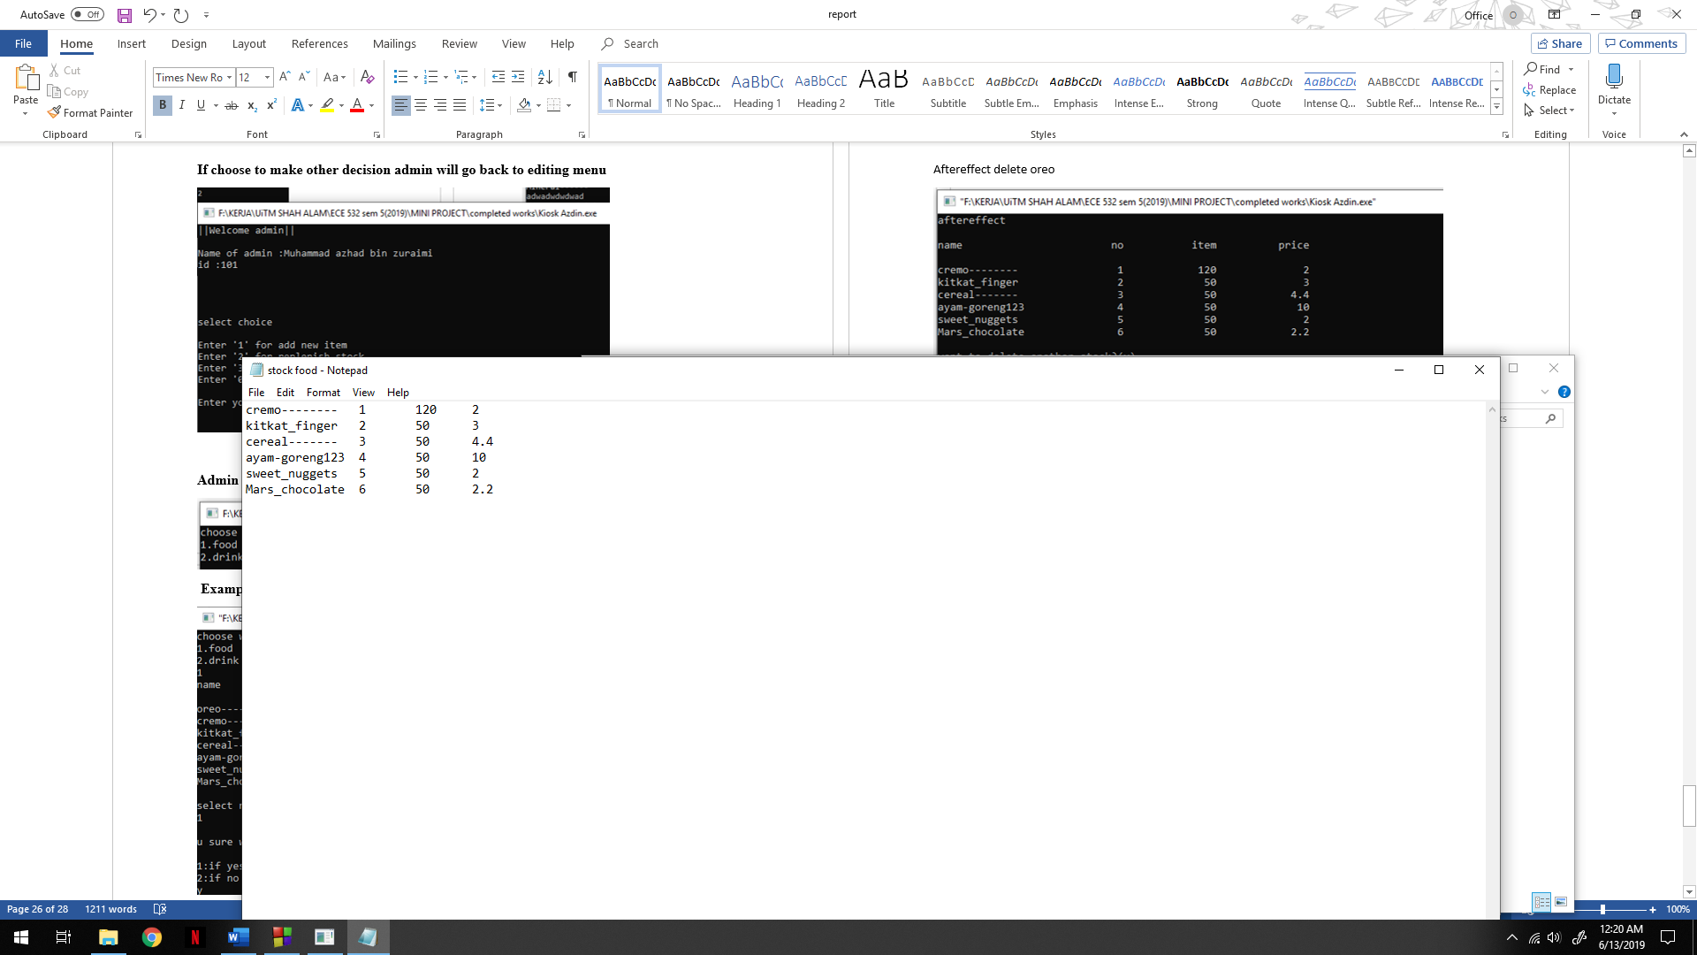

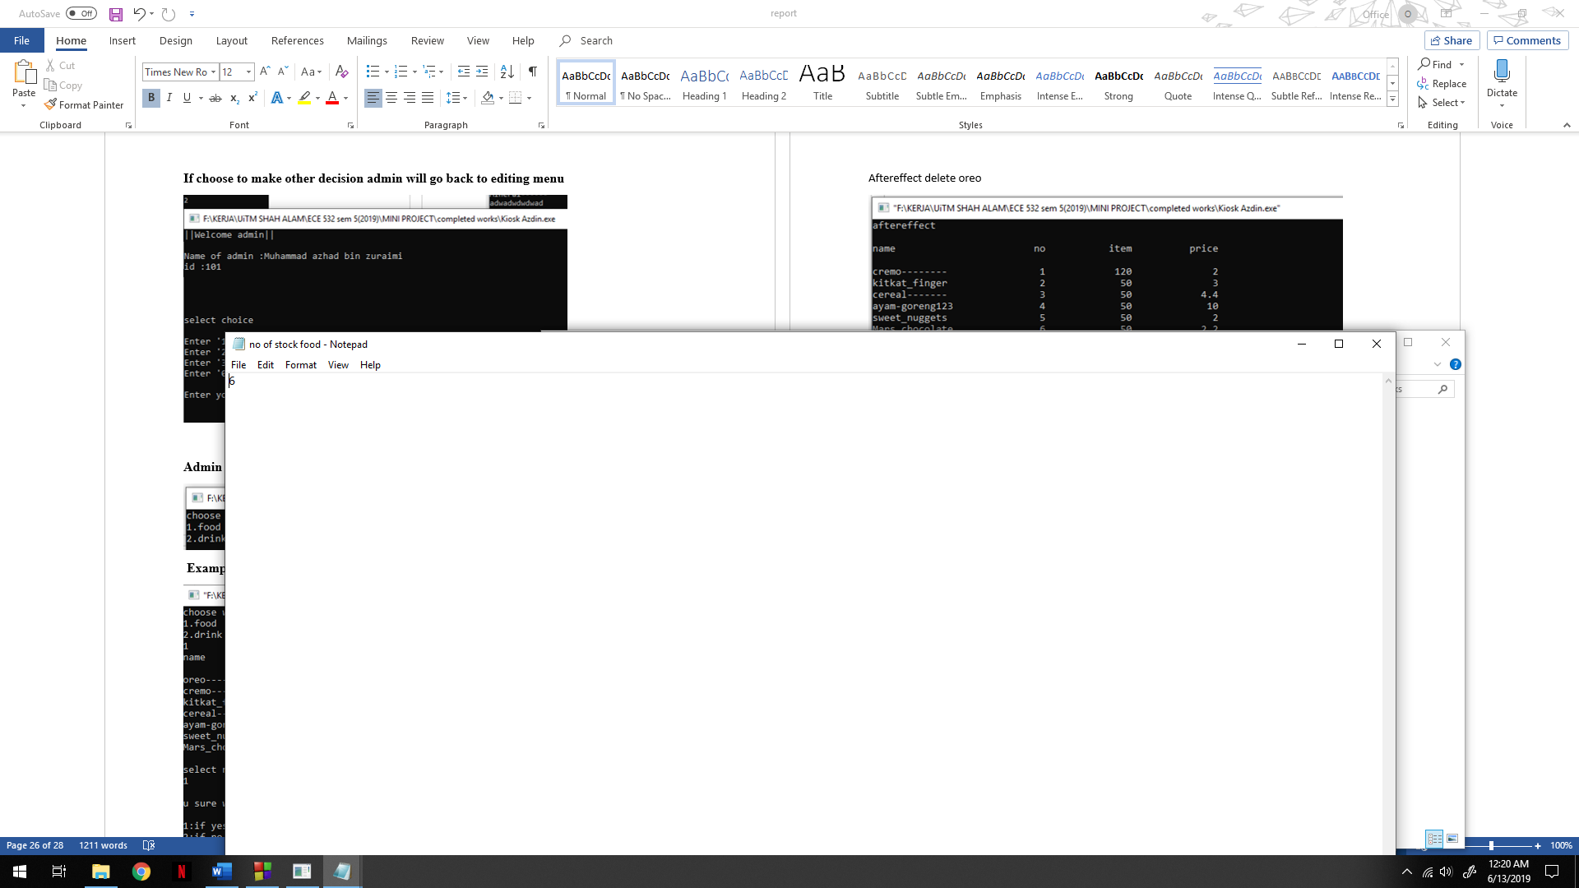

**If choose delete another stock(middle node) drink.**

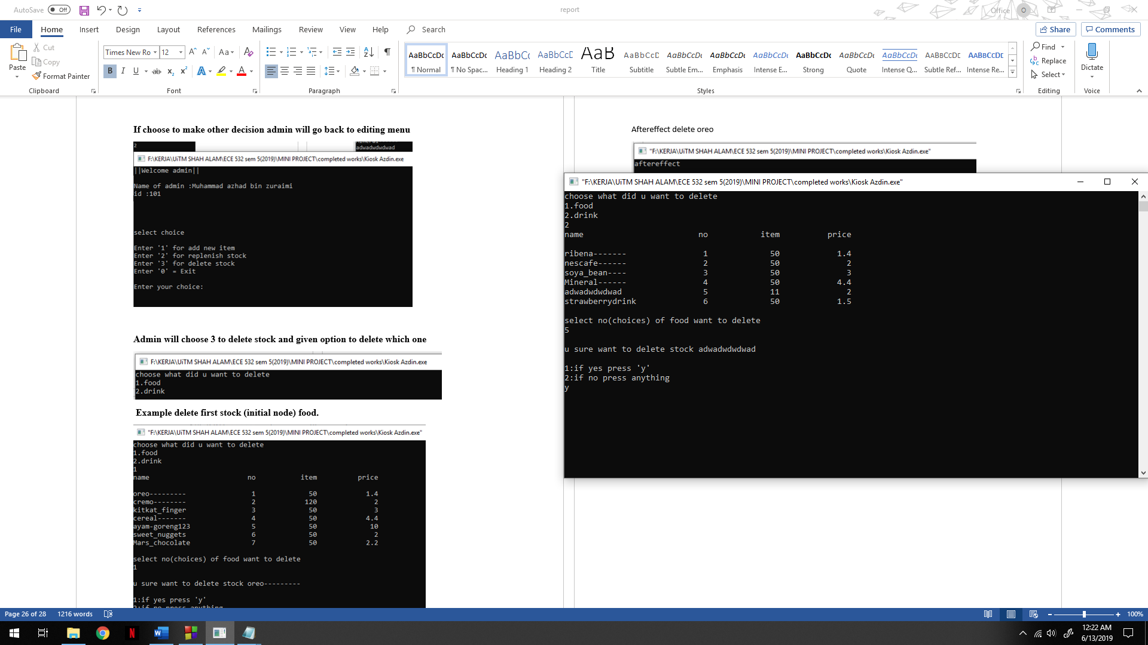

**The aftereffect delete drink adwadwdwdwad**

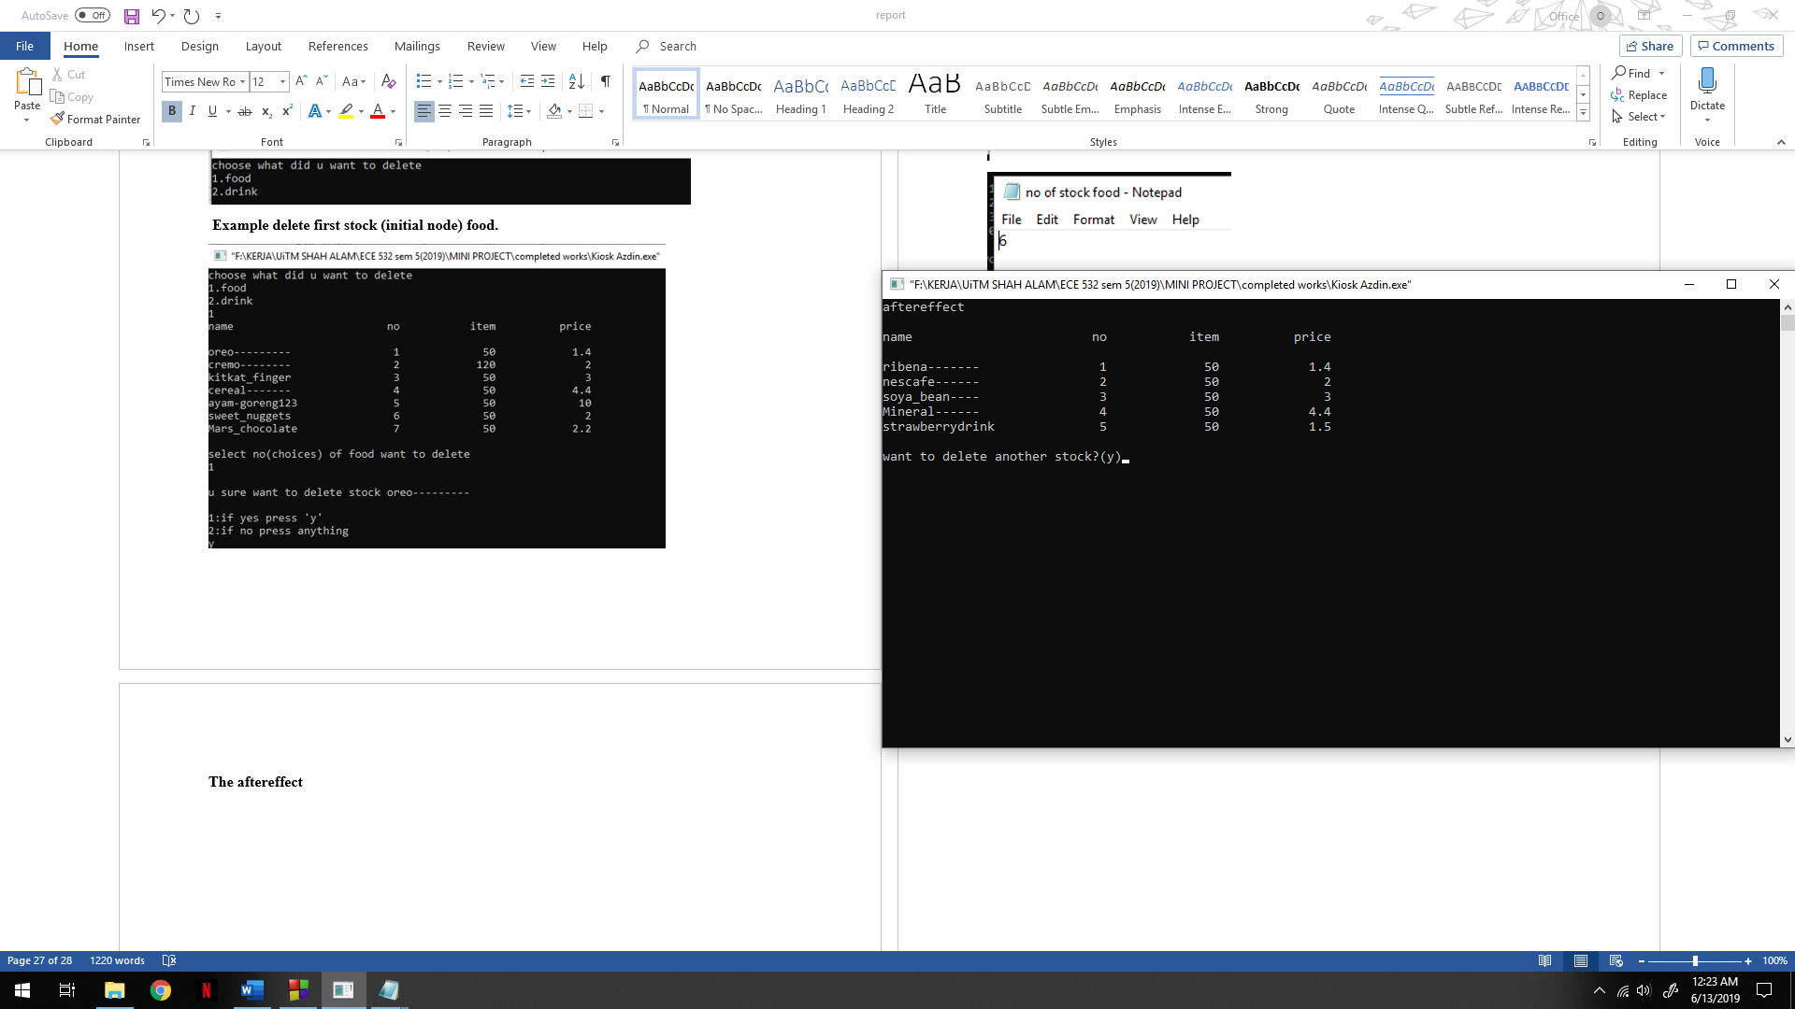

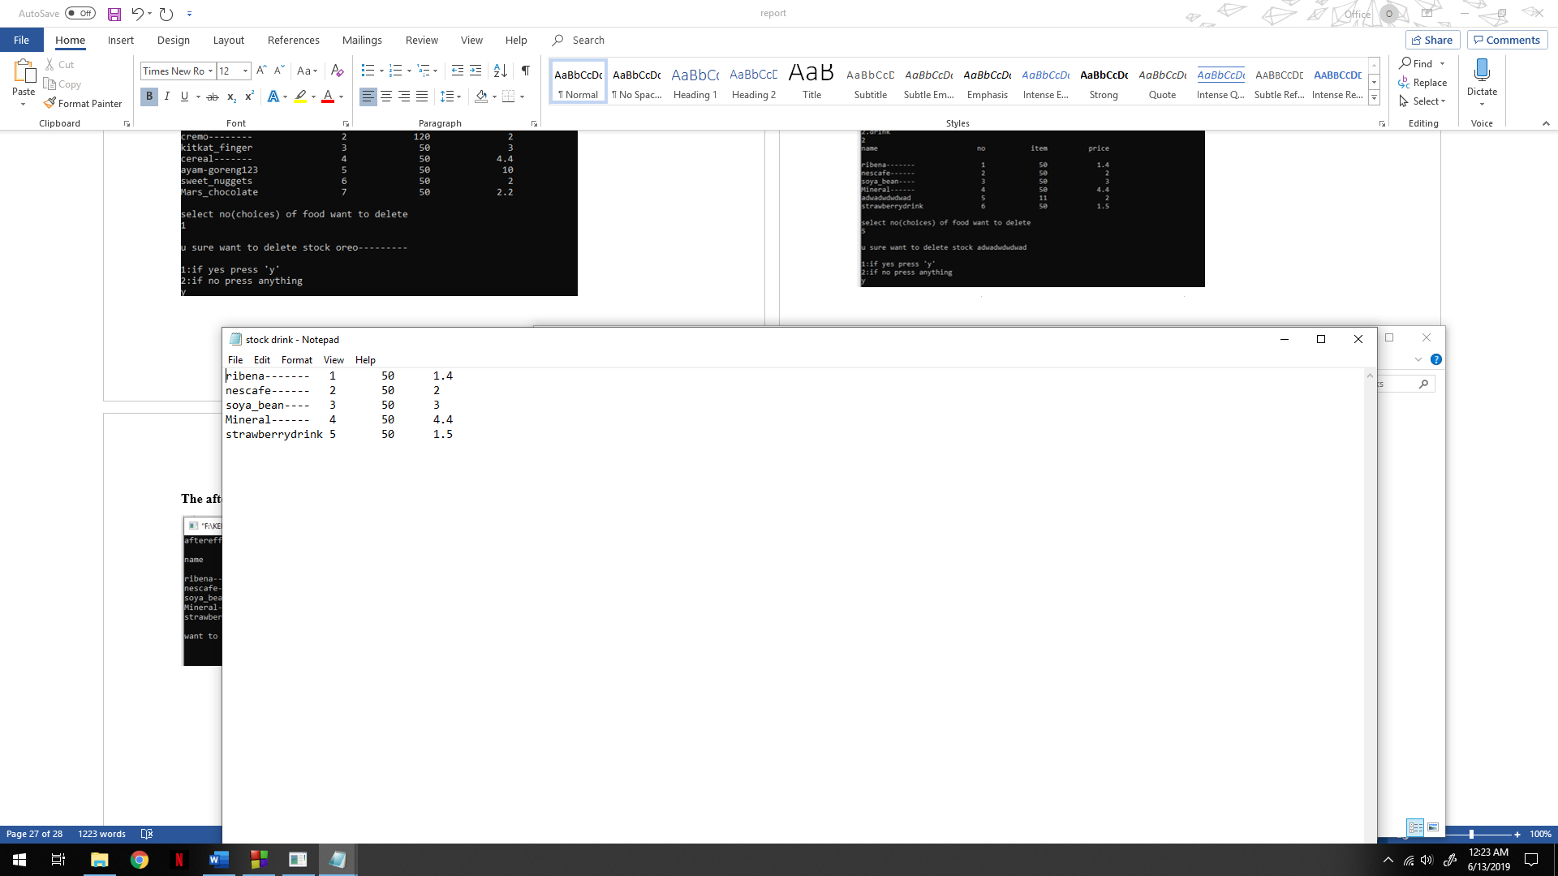

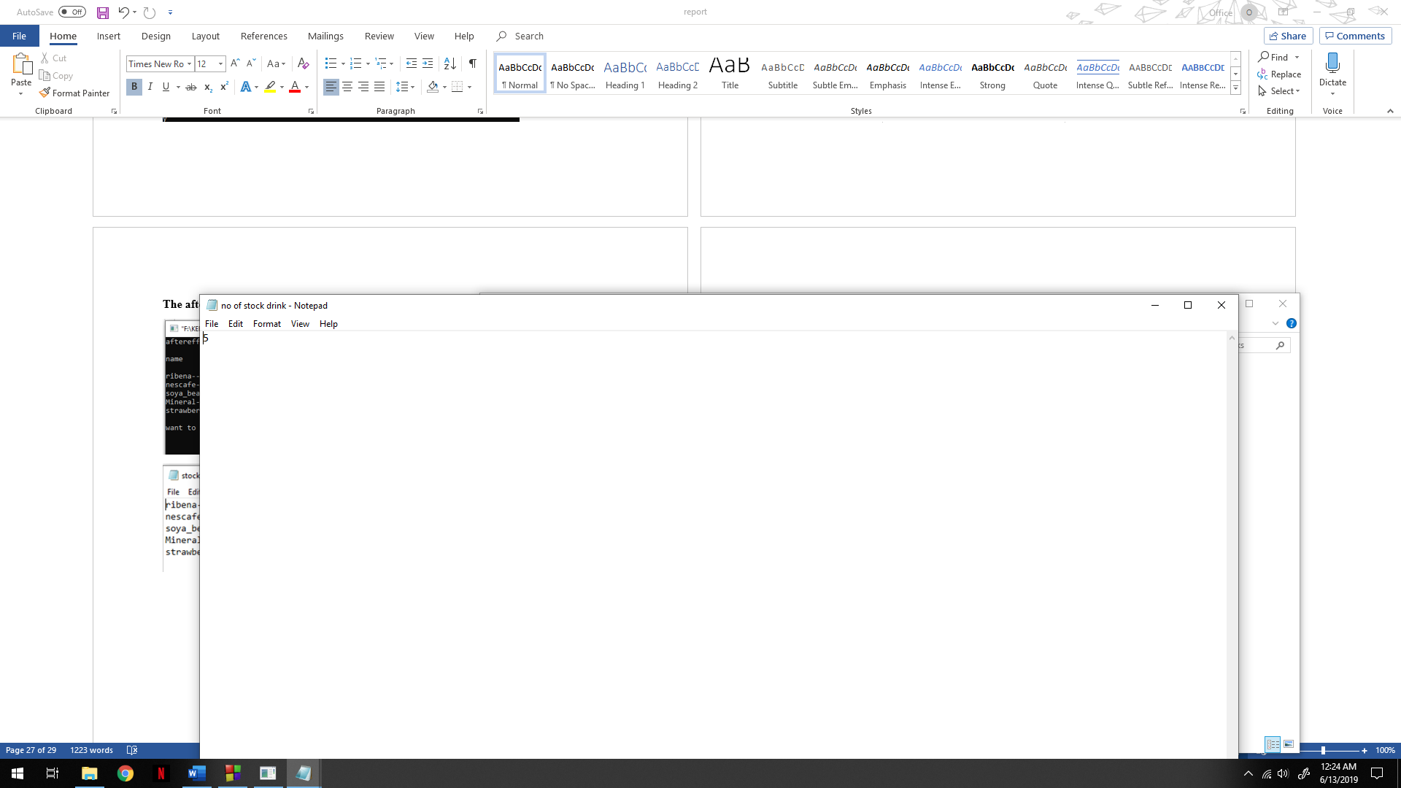

**Example want to delete food (last node) Mars_chocolate**

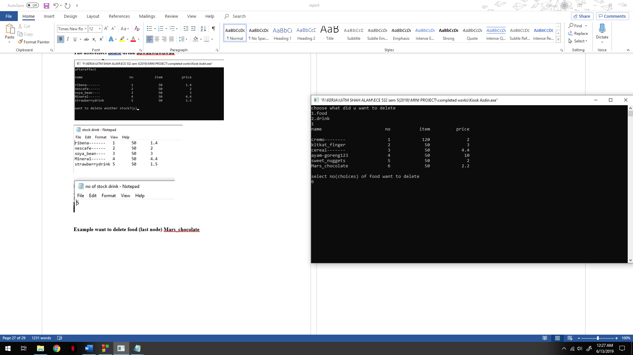

**The after effect delete Mars_chocolate**

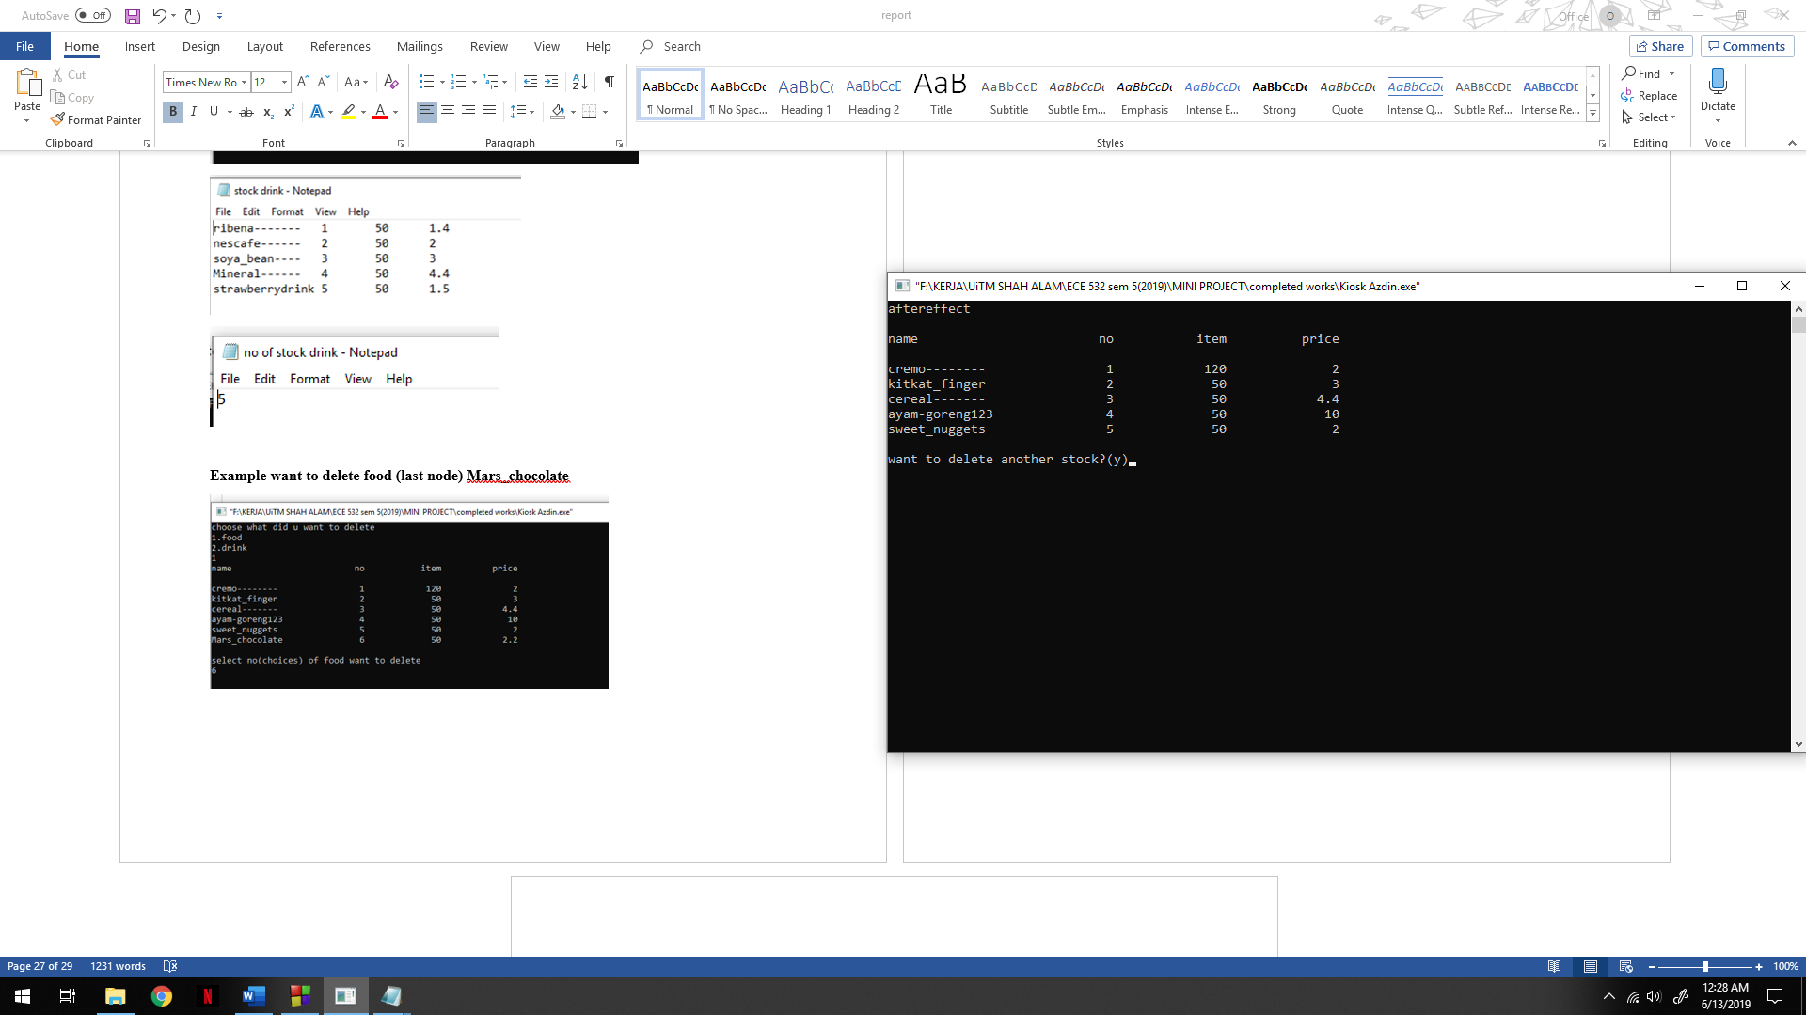

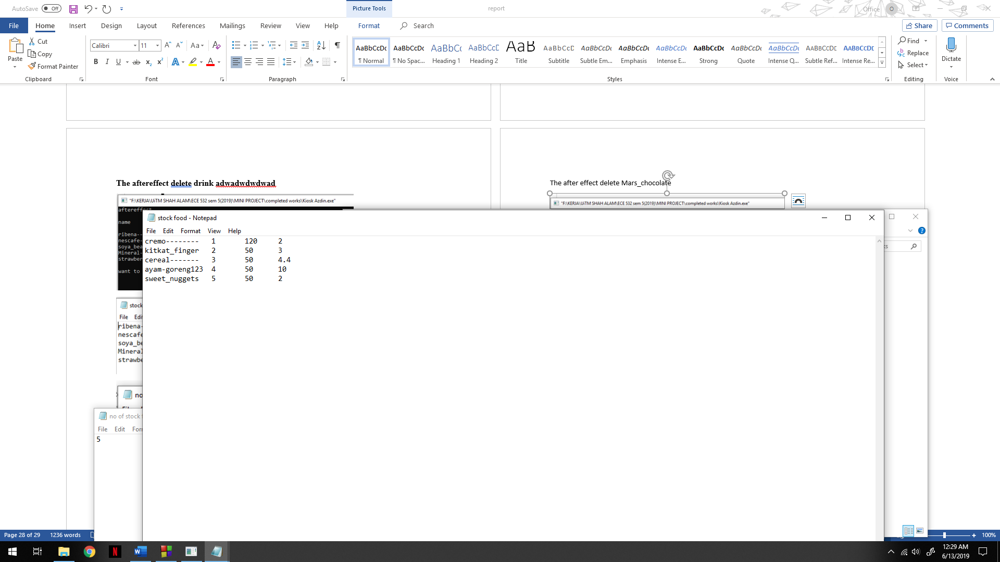

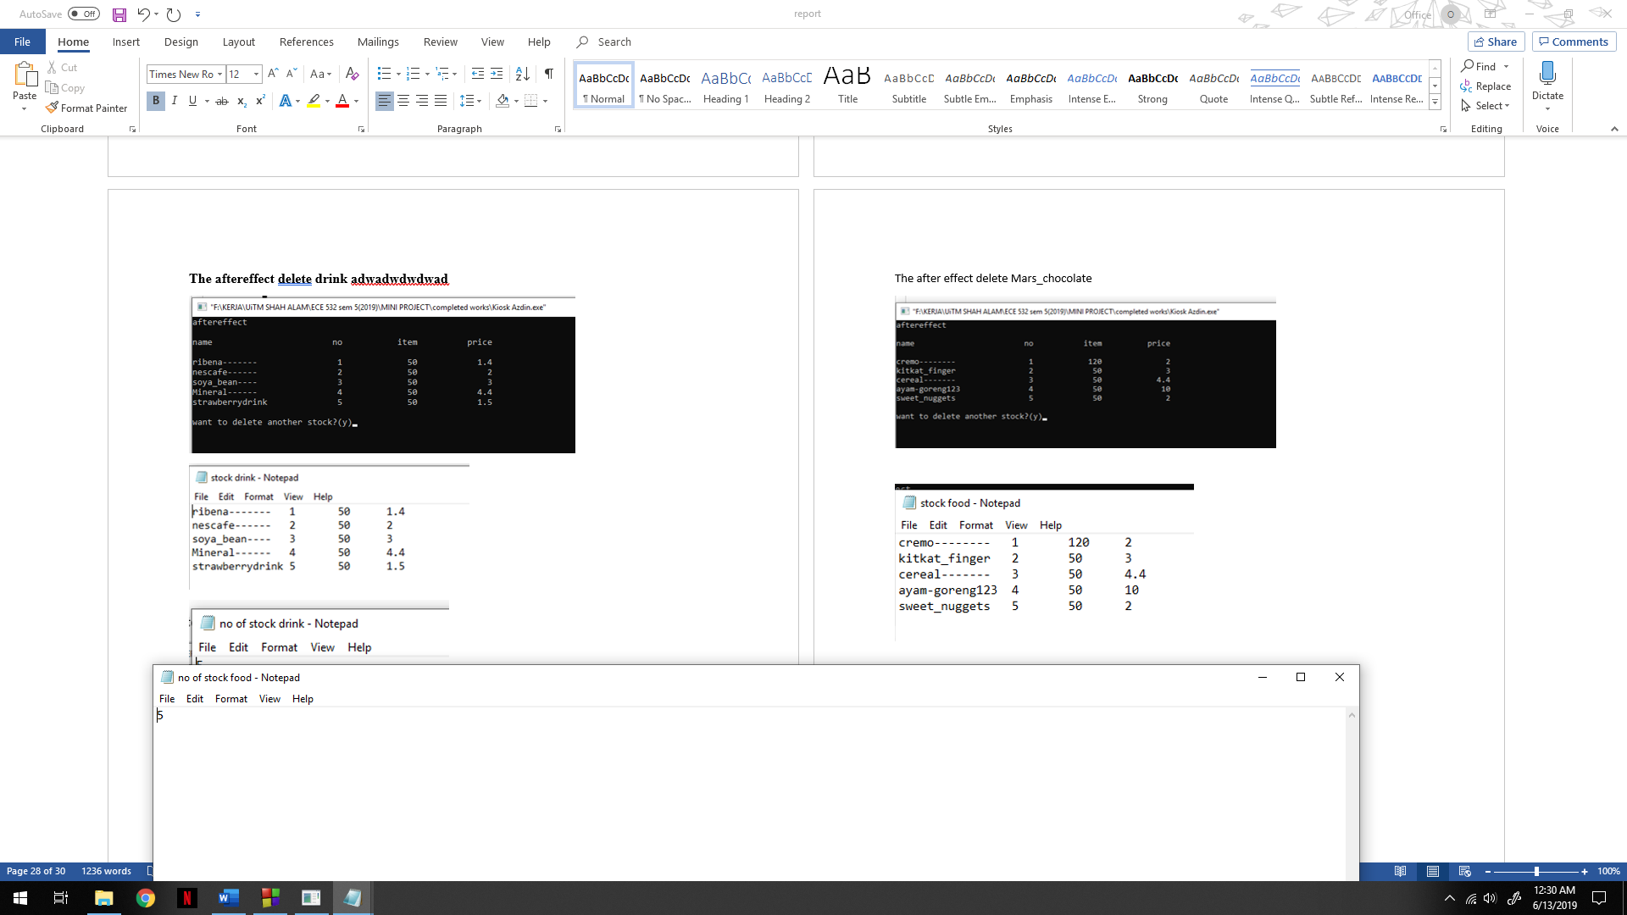

**After admin had made all editing their wanted, admin will be welcome by kiosk**

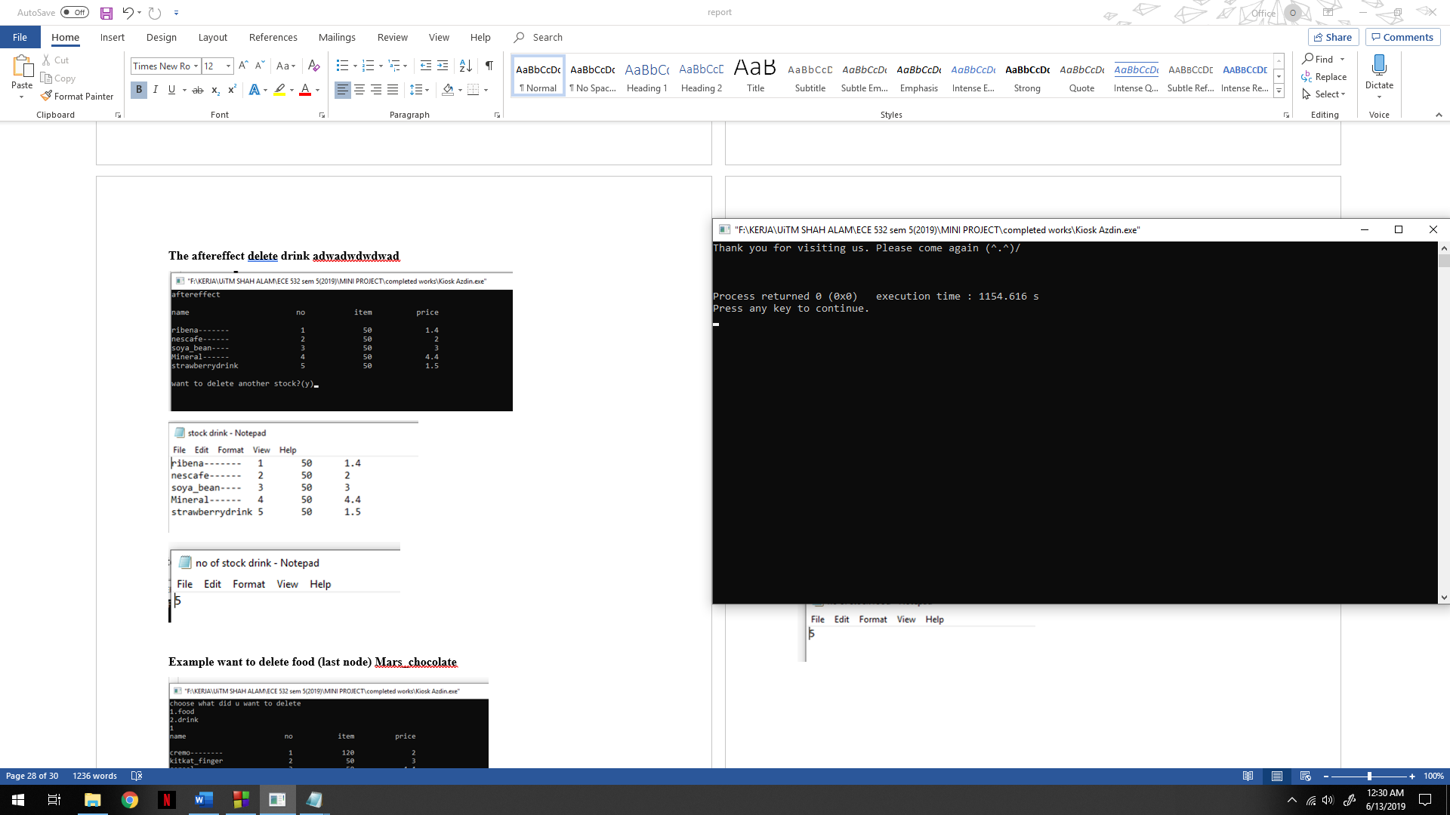

**CONCLUSION**

In conclusion, the mobile phone online kiosk is successful with c++ coding that have ability to Insert data, Store data in a file, Update data, Delete data, Search a particular data, Display data according to user requirement and included with the fundamental of C++ programming codes such as selection (if … else / switch …case), iteration (while / for / do …. While), function, array and linked list. The development mobile phone online kiosk can reach out consumers to purchase products such as foods, drinks and utilities easier throughout online mobile applications. It provides convenience for consumers mostly advantages to busy lifestyle or live far away from nearest store or market. This mobile phone online kiosk can use 24 hours a day, 7 days a week service for purchase and delivery of a product for consumers. This mobile phone online kiosk help consumer to make price comparison before purchasing a product. Admin can add new stock, update new stock, or delete new stock. The only problem is producer cannot make only one file to store all data because it will be too complex for coding and not enough knowledge to make it.